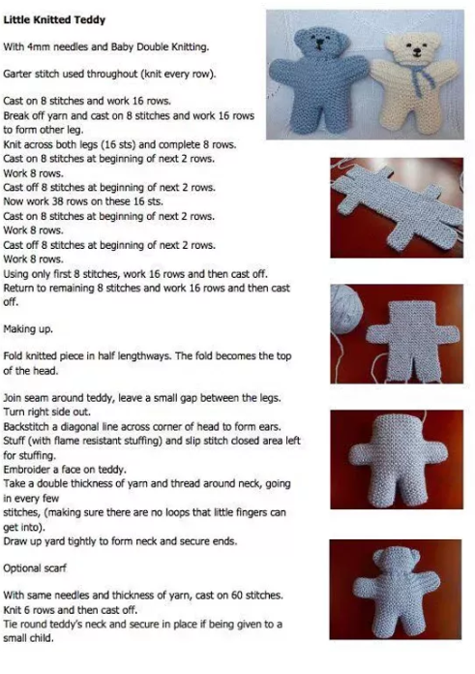
Little Knitted Teddies for SWAN Appeal
simple one piece pattern

simple three piece pattern

Made with oddments of brown double knitting yarn, a length of blue and black. A short piece of ribbon and a small amount of toy stuffing. 3mm single pointed needles were used. It is about 9 cm tall when finished.
Abbreviations : k – knit. p – purl. st – stitch. tog-together. st-st – Stocking Stitch (k1row, p1row).
Body & Head – Make 1
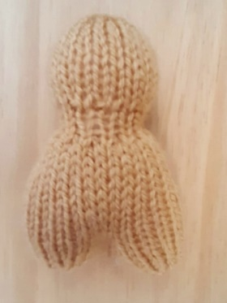
Starting at the feet, with brown, cast on 7 sts
Purl 1 row
Next: increase into every stitch (14 sts)
Starting with a purl row, st-st 5 rows
Place all stitches on a stitch holder and make another leg the same.
Knit along all stitches and the stitches on the stitch holder too (28 sts)
Starting with a purl row, st-st 11 rows
Next: k2tog to end (14 sts)
Starting with a purl row, st-st 3 rows
Next: (inc1, inc1, k1) to last 2 sts, inc1, inc1 (24 sts)
Starting with a purl row, st-st 9 rows
Next: k2tog to end (12 sts)
Purl 1 row
Draw thread through the remaining stitches and pull tight.
Gather the cast on stitches. Sew down the row ends of the head and up the legs. Add stuffing and seal up.
Arms- Make 2
With brown, cast on 6 sts
Purl 1 row
Next: increase into every stitch (12 sts)
Starting with a purl row, st-st 5 rows
Next: k2tog to end (6 sts)
Draw thread through the remaining stitches and pull tight
Sew down the row ends. Add a little toy stuffing and seal up. Attach the arms at either side of the body piece at the shoulders

Ears – Make 2
With brown, cast on 14 sts
Knit 1 row
Next: k2tog to end (7 sts)
Draw thread through the remaining stitches and pull tight.
Attach the ears to the head, one at either side so the bound off stitches are in the centre of the ear. Curl the ear a little as they are sewn.
To finish, sew a triangle in blue to the front of the face to represent the nose. Take a blue thread and go from the bottom of the nose, down and under the chin. Sew two eyes in black just above the nose.
Wrap some blue ribbon round the neck in a bow.
If you enjoyed this pattern and want to share it, please redirect your friends to this website instead of sharing the text and pictures. Thanks.
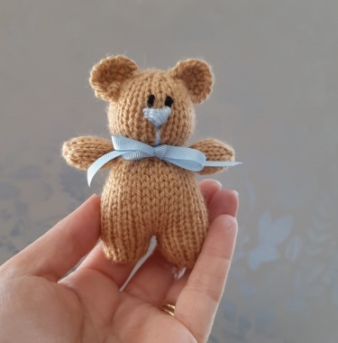
© Copyright 2020 Knitting by Post Ltd

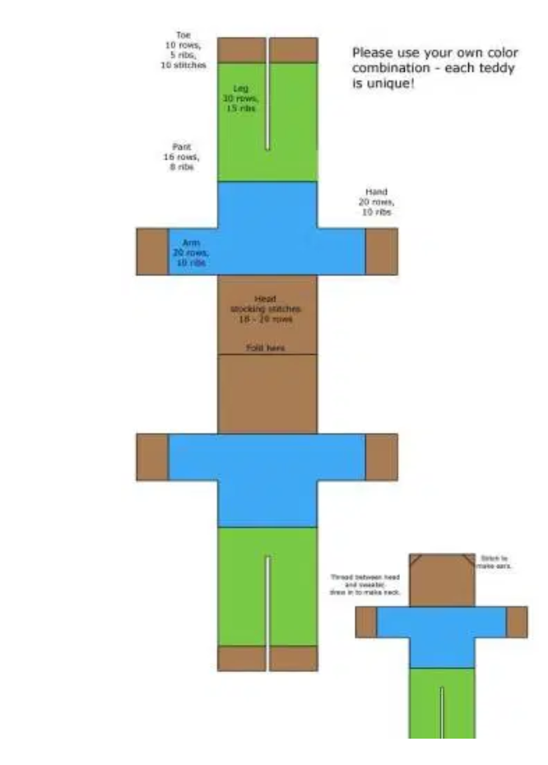
Little Crochet/ knit Teddies for SWAN Appeal
simple one piece pattern

