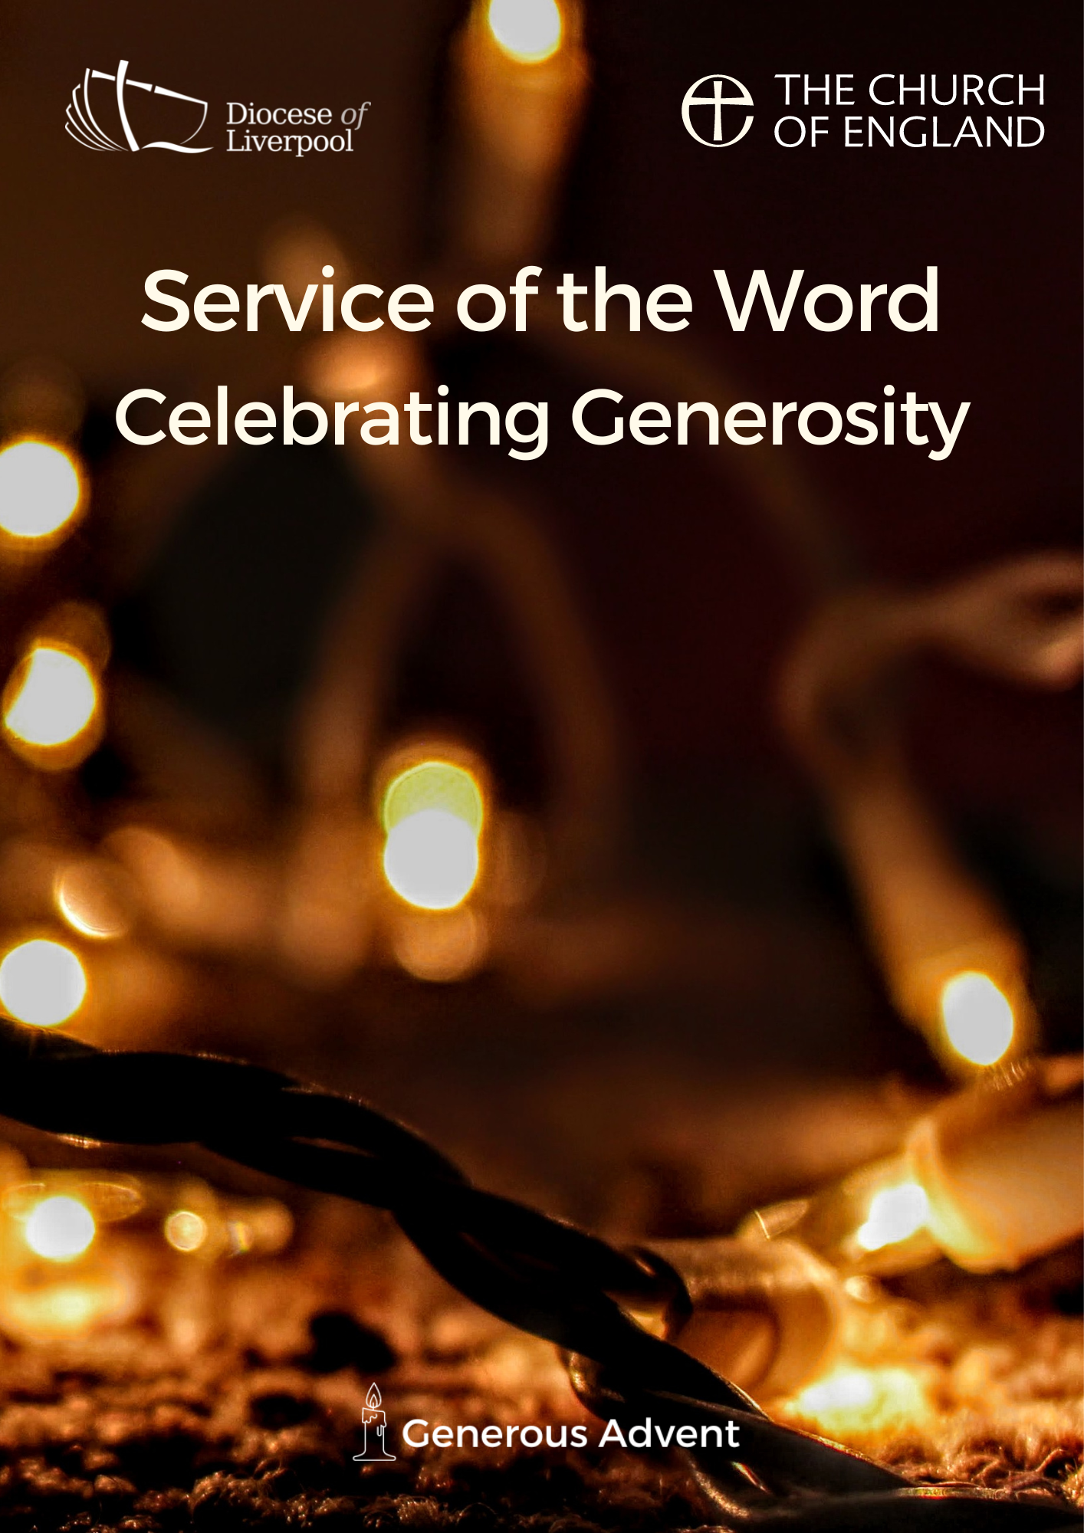

PREPARATION

In preparation for this act of worship, you might wish to pray privately this Ignatian Prayer for Generosity.

Lord, teach me to be generous.
Teach me to serve you as you deserve;
to give and not to count the cost,
to fight and not to heed the wounds,
to toil and not to seek for rest,
to labour and not to ask for reward,
save that of knowing that I do your will.
Amen.
St Ignatius of Loyola

PREPARATION

In the name of the Father,
and of the Son,
and of the Holy Spirit.
Amen.

God is able to provide us with every blessing in abundance,
so that by always having enough of everything,
we may share abundantly in every good work.
cf. 2 Corinthians 9.8

Let everything be said and done in the name of the Lord Jesus,
giving thanks to God through Jesus Christ.
Let us bring our gifts to the Lord
that they may be used for his glory.
May the Spirit of God fill our hearts
as we come to meet him in this place.

Words of welcome or introduction may be said.

In Advent the lighting of the Advent candle may take place here.

Blessed are you, God of Abraham and Sarah,
and all the patriarchs of old.
Your love is revealed to us in Jesus Christ,
Son of God and Son of David.
Give us thankful hearts as we prepare to celebrate his birth
and make our hearts ready
to welcome your generous Spirit to dwell among us.
Make us one as we walk with Christ
today and for ever.
Amen

Prayers of Penitence

As those who know the generosity of God,
let us confess our sins,
especially the ways in which we take his good gifts for granted.

Father, in all things you are generous towards us,
yet we have sown sparingly;
Lord, have mercy.
Lord, have mercy.

Jesus, you show us the way of humility,
yet we have given reluctantly;
Christ, have mercy.
Christ, have mercy.

Holy Spirit, you show us the gift of grace,
yet we have loved grudgingly;
Lord, have mercy.
Lord, have mercy.

Almighty God,
who in Jesus Christ has given us
a kingdom that cannot be destroyed,
forgive us our sins,
open our eyes to God’s truth,
strengthen us to do God’s will
and give us the joy of his kingdom,
through Jesus Christ our Lord.
Amen.

Canticle: A Song of David

Splendour and majesty are yours, O God;
you are exalted as head over all.

1 Blessed are you, God of Israel, for ever and ever,
for yours is the greatness, the power,
the glory, the splendour and the majesty.
2 Everything in heaven and on earth is yours;
yours is the kingdom, O Lord,
and you are exalted as head over all.
3 Riches and honour come from you
and you rule over all.
4 In your hand are power and might;
yours it is to give power and strength to all.
5 And now we give you thanks, our God,
and praise your glorious name.
6 For all things come from you,
and of your own have we given you.
1 Chronicles 29.10b-13,14b

Glory to the Father and to the Son
and to the Holy Spirit;
as it was in the beginning is now
and shall be for ever. Amen.

Splendour and majesty are yours, O God;
you are exalted as head over all.

The Collect
God of grace, ever creating and restoring,
you breathe life into all things
and embrace us with an everlasting love;
help us to grow in wonder and awe,
to embody a spirit of gratitude,
and to dream generous dreams;
that, in gathering what we have,
we may graciously offer ourselves
to accomplish what you will,
in Jesus Christ our Lord. Amen.

The collect for the day may also be said here
A children's talk or an all age activity may take place at this point

THE LITURGY OF THE WORD
The First Reading
But as for you, man of God, shun all this; pursue righteousness, godliness, faith, love, endurance, gentleness. Fight the good fight of the faith; take hold of the eternal life, to which you were called and for which you made the good confession in the presence of many witnesses. In the presence of God, who gives life to all things, and of Christ Jesus, who in his testimony before Pontius Pilate made the good confession, I charge you to keep the commandment without spot or blame until the manifestation of our Lord Jesus Christ, which he will bring about at the right time—he who is the blessed and only Sovereign, the King of kings and Lord of lords. It is he alone who has immortality and dwells in unapproachable light, whom no one has ever seen or can see; to him be honour and eternal dominion. Amen.
As for those who in the present age are rich, command them not to be haughty, or to set their hopes on the uncertainty of riches, but rather on God who richly provides us with everything for our enjoyment. They are to do good, to be rich in good works, generous, and ready to share, thus storing up for themselves the treasure of a good foundation for the future, so that they may take hold of the life that really is life.
1 Timothy 6.11-19
Psalmody: Psalm 104.26-36

I will sing to the Lord as long as I live.

26 O Lord, how manifold are your works!
In wisdom you have made them all;
the earth is full of your creatures.
27 There is the sea, spread far and wide,
and there move creatures beyond number, both small and great.
28 There go the ships, and there is that Leviathan
which you have made to play in the deep.
29 All of these look to you
to give them their food in due season.
30 When you give it them, they gather it;
you open your hand and they are filled with good.
31 When you hide your face they are troubled;
when you take away their breath,
they die and return again to the dust.
32 When you send forth your spirit, they are created,
and you renew the face of the earth.
33 May the glory of the Lord endure for ever;
may the Lord rejoice in his works;
34 He looks on the earth and it trembles;
he touches the mountains and they smoke.
35 I will sing to the Lord as long as I live;
I will make music to my God while I have my being.
36 So shall my song please him
while I rejoice in the Lord.

Glory to the Father and to the Son
and to the Holy Spirit;
as it was in the beginning is now
and shall be for ever. Amen.

I will sing to the Lord as long as I live.
Gospel Reading

Hear the Gospel of our Lord Jesus Christ, according to Matthew.
Glory to you, O Lord.

[Jesus said,] ‘Do not store up for yourselves treasures on earth, where moth and rust consume and where thieves break in and steal; but store up for yourselves treasures in heaven, where neither moth nor rust consumes and where thieves do not break in and steal. For where your treasure is, there your heart will be also. The eye is the lamp of the body. So, if your eye is healthy, your whole body will be full of light; but if your eye is unhealthy, your whole body will be full of darkness. If then the light in you is darkness, how great is the darkness! No one can serve two masters; for a slave will either hate the one and love the other, or be devoted to the one and despise the other. You cannot serve God and wealth.

‘Therefore I tell you, do not worry about your life, what you will eat or what you will drink, or about your body, what you will wear. Is not life more than food, and the body more than clothing? Look at the birds of the air; they neither sow nor reap nor gather into barns, and yet your heavenly Father feeds them. Are you not of more value than they? And can any of you by worrying add a single hour to your span of life? And why do you worry about clothing? Consider the lilies of the field, how they grow; they neither toil nor spin, yet I tell you, even Solomon in all his glory was not clothed like one of these. But if God so clothes the grass of the field, which is alive today and tomorrow is thrown into the oven, will he not much more clothe you—you of little faith? Therefore do not worry, saying, “What will we eat?” or “What will we drink?” or “What will we wear?” For it is the Gentiles who strive for all these things; and indeed your heavenly Father knows that you need all these things. But strive first for the kingdom of God and his righteousness, and all these things will be given to you as well.
Matthew 6.19-33

This is the Gospel of the Lord.
Praise to you, O Christ.

The Sermon
Affirmation of Faith

Let us affirm our faith in Jesus Christ the Son of God.

Though he was divine,
he did not cling to equality with God,
but made himself nothing.
Taking the form of a slave,
he was born in human likeness.

He humbled himself
and was obedient to death,
even the death of the cross.
Therefore God has raised him on high,
and given him the name above every name:
that at the name of Jesus
every knee should bow,
and every voice proclaim that Jesus Christ is Lord,
to the glory of God the Father.
Amen.
cf Philippians 2.6-11

PRAYERS
A Litany of Generosity
Let us give thanks to God
for his gifts so generous given to us,
and for the blessings we are called to share.

For recognising that all things come from you,
for remembering that we are stewards of your gifts,
for wisely using the resources entrusted to us.
We offer ourselves to you, O God.
For rejoicing in the beauty of creation,
for the care of your world,
for sharing the fruits of creation equally among all people.
We offer ourselves to you, O God.

For encountering the joy of giving,
for humility in putting others’ needs before our own,
for embracing the privilege of sharing in the ministry to the saints.
We offer ourselves to you, O God.

For courage in offering sacrificial generosity,
for giving to be an act of worship,
for grace in offering our souls and bodies to be a living sacrifice.
We offer ourselves to you, O God.

For all financial gifts offered to your Church,
for freely giving as we have received,
for giving and not counting the cost.
We offer ourselves to you, O God.

For releasing our hold on material possessions,
for contentment in what we have,
for trust in letting go.
We offer ourselves to you, O God.

For generosity in love, encouragement and hope,
for openness in invitation and hospitality,
for wisdom in the gift of friendship.
We offer ourselves to you, O God.

For serving you as you deserve,
for following our calling as your disciples,
for serving you with gladness of heart.
We offer ourselves to you, O God.

For being a blessing through the blessings we receive,
for generosity which enables mission,
for sharing abundantly in every good work.
We offer ourselves to you, O God.

For living a generous life,
for our actions to point beyond themselves,
for our generosity to be an expression of love and gratitude.
We offer ourselves to you, O God.

Intercessions

Intercessions are offered, and may end with;

Source of all life and giver of all that is good,
hear our prayer,
and make us one in heart and mind
to serve you with joy forever.
Amen.

The Offering

An offering is taken, which may be virtual, giving time for people to reflect on gifts given electronically.

God of all creation,
the source of life and giver of all good things;
through your goodness you have blessed us with these gifts.
With them we offer our lives;
that we may be used to serve others,
and give you glory.
We make our prayer
in the name of Jesus Christ, our Lord.
Amen.

THE DISMISSAL

The God of hope fill us with every blessing,
that we may share in every good work;
and the blessing of God almighty,
the Father, the Son, and the Holy Spirit,
be among you and remain with you always.
Amen.

Go in peace to love and serve the Lord.
In the name of Christ. Amen.

Material in this order of service is taken from Common Worship, copyright © The Archbishops’ Council 2000-2006 and is used here with permission. www.commonworship.com. This order has been compiled by Sammi Tooze. The prayer for the candle lighting is adapted from Common Worship: Times and Seasons. This compilation is copyright © The National Giving Team 2021.

