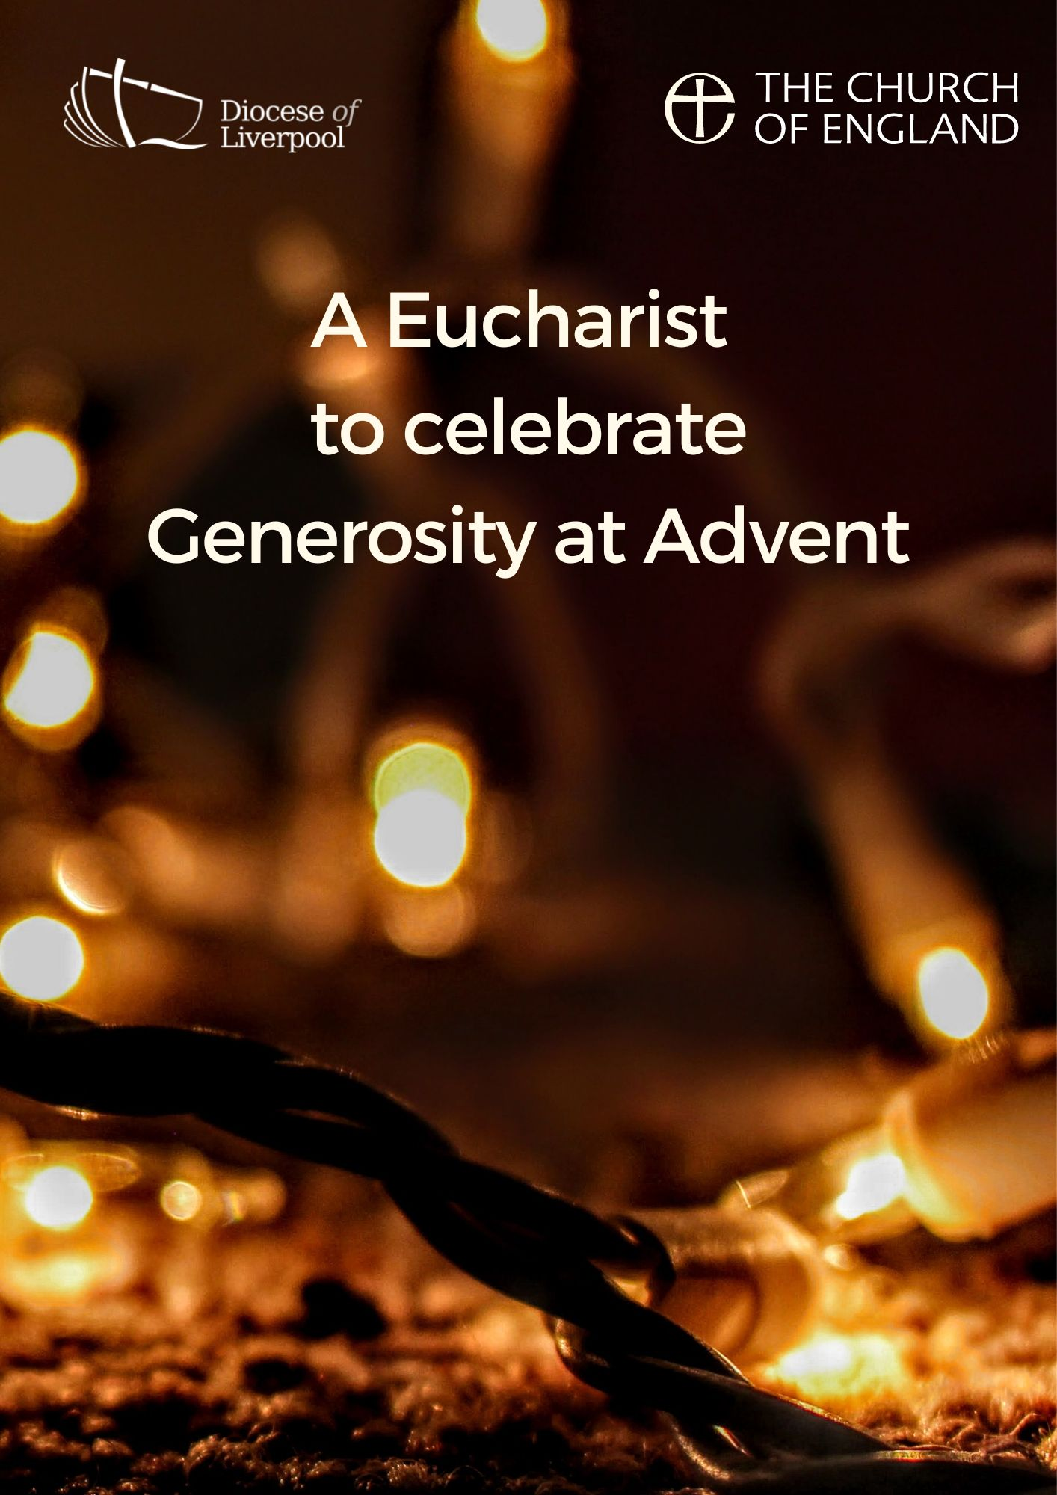

PREPARATION

In preparation for this act of worship, you might wish to pray privately this Ignatian Prayer for Generosity.

Lord, teach me to be generous.
Teach me to serve you as you deserve;
to give and not to count the cost,
to fight and not to heed the wounds,
to toil and not to seek for rest,
to labour and not to ask for reward,
save that of knowing that I do your will.
Amen.
St Ignatius of Loyola

THE GATHERING

In the name of the Father,
and of the Son,
and of the Holy Spirit.
Amen.

God is able to provide us with every blessing in abundance,
so that by always having enough of everything,
we may share abundantly in every good work.
cf. 2 Corinthians 9.8

Let everything be said and done in the name of the Lord Jesus,
giving thanks to God through Jesus Christ.
Let us bring our gifts to the Lord
that they may be used for his glory.
May the Spirit of God fill our hearts
as we come to meet him in this place.

Words of welcome or introduction may be said.

In Advent the lighting of the Advent candle may take place here or after Holy Communion, as desired.

Prayers of Penitence

As those who know the generosity of God,
let us confess our sins,
especially the ways in which we take his good gifts for granted.

Father, in all things you are generous towards us,
yet we have sown sparingly;
Lord, have mercy.
Lord, have mercy.

Jesus, you show us the way of humility,
yet we have given reluctantly;
Christ, have mercy.
Christ, have mercy.

Holy Spirit, you show us the gift of grace,
yet we have loved grudgingly;
Lord, have mercy.
Lord, have mercy.

Almighty God,
who in Jesus Christ has given us
a kingdom that cannot be destroyed,
forgive us our sins,
open our eyes to God’s truth,
strengthen us to do God’s will
and give us the joy of his kingdom,
through Jesus Christ our Lord.
Amen.

Gloria in Excelsis

Gloria in excelsis may be used.
Glory to God in the highest,
and peace to his people on earth.
Lord God, heavenly King,
almighty God and Father,
we worship you, we give you thanks,
we praise you for your glory.
Lord Jesus Christ, only Son of the Father,
Lord God, Lamb of God,
you take away the sin of the world:
have mercy on us;
you are seated at the right hand of the Father:
receive our prayer.
For you alone are the Holy One,
you alone are the Lord,
you alone are the Most High, Jesus Christ,
with the Holy Spirit,
in the glory of God the Father. Amen.

The Collect
God of grace, ever creating and restoring,
you breathe life into all things
and embrace us with an everlasting love;
help us to grow in wonder and awe,
to embody a spirit of gratitude,
and to dream generous dreams;
that, in gathering what we have,
we may graciously offer ourselves
to accomplish what you will,
in Jesus Christ our Lord. Amen.

The collect for the day may also be said here
A children's talk or an all age activity may take place at this point
THE LITURGY OF THE WORD
The First Reading

But as for you, man of God, shun all this; pursue righteousness, godliness, faith, love, endurance, gentleness. Fight the good fight of the faith; take hold of the eternal life, to which you were called and for which you made the good confession in the presence of many witnesses. In the presence of God, who gives life to all things, and of Christ Jesus, who in his testimony before Pontius Pilate made the good confession, I charge you to keep the commandment without spot or blame until the manifestation of our Lord Jesus Christ, which he will bring about at the right time—he who is the blessed and only Sovereign, the King of kings and Lord of lords. It is he alone who has immortality and dwells in unapproachable light, whom no one has ever seen or can see; to him be honour and eternal dominion. Amen.

As for those who in the present age are rich, command them not to be haughty, or to set their hopes on the uncertainty of riches, but rather on God who richly provides us with everything for our enjoyment. They are to do good, to be rich in good works, generous, and ready to share, thus storing up for themselves the treasure of a good foundation for the future, so that they may take hold of the life that really is life.
1 Timothy 6.11-19

Gospel Reading

Hear the Gospel of our Lord Jesus Christ, according to Matthew.
Glory to you, O Lord.

[Jesus said,] ‘Do not store up for yourselves treasures on earth, where moth and rust consume and where thieves break in and steal; but store up for yourselves treasures in heaven, where neither moth nor rust consumes and where thieves do not break in and steal. For where your treasure is, there your heart will be also.
‘The eye is the lamp of the body. So, if your eye is healthy, your whole body will be full of light; but if your eye is unhealthy, your whole body will be full of darkness. If then the light in you is darkness, how great is the darkness!
‘No one can serve two masters; for a slave will either hate the one and love the other, or be devoted to the one and despise the other. You cannot serve God and wealth.

‘Therefore I tell you, do not worry about your life, what you will eat or what you will drink, or about your body, what you will wear. Is not life more than food, and the body more than clothing? Look at the birds of the air; they neither sow nor reap nor gather into barns, and yet your heavenly Father feeds them. Are you not of more value than they? And can any of you by worrying add a single hour to your span of life? And why do you worry about clothing? Consider the lilies of the field, how they grow; they neither toil nor spin, yet I tell you, even Solomon in all his glory was not clothed like one of these. But if God so clothes the grass of the field, which is alive today and tomorrow is thrown into the oven, will he not much more clothe you—you of little faith? Therefore do not worry, saying, “What will we eat?” or “What will we drink?” or “What will we wear?” For it is the Gentiles who strive for all these things; and indeed your heavenly Father knows that you need all these things. But strive first for the kingdom of God and his righteousness, and all these things will be given to you as well.
Matthew 6.19-33

This is the Gospel of the Lord.
Praise to you, O Christ.

The sermon
The Creed
We believe in one God,
the Father, the Almighty,
maker of heaven and earth,
of all that is, seen and unseen.

We believe in one Lord, Jesus Christ,
the only Son of God,
eternally begotten of the Father,
God from God, Light from Light,
true God from true God,
begotten, not made,
of one Being with the Father;
through him all things were made.
For us and for our salvation he came down from heaven,
was incarnate from the Holy Spirit and the Virgin Mary
and was made man.
For our sake he was crucified under Pontius Pilate;
he suffered death and was buried.
On the third day he rose again
in accordance with the Scriptures;
he ascended into heaven
and is seated at the right hand of the Father.
He will come again in glory to judge the living and the dead,
and his kingdom will have no end.

We believe in the Holy Spirit,
the Lord, the giver of life,
who proceeds from the Father and the Son,
who with the Father and the Son is worshipped and glorified,
who has spoken through the prophets.
We believe in one holy catholic and apostolic Church.
We acknowledge one baptism for the forgiveness of sins.
We look for the resurrection of the dead,
and the life of the world to come. Amen.
PRAYER
A Litany of Generosity

Let us give thanks to God
for his gifts so generous given to us,
and for the blessings we are called to share.

For recognising that all things come from you,
for remembering that we are stewards of your gifts,
for wisely using the resources entrusted to us.
We offer ourselves to you, O God.

For rejoicing in the beauty of creation,
for the care of your world,
for sharing the gifts of creation equally among all people.
We offer ourselves to you, O God.

For encountering the joy of giving,
for humility in putting others’ needs before our own,
for embracing the privilege of sharing in the ministry to the saints.
We offer ourselves to you, O God.

For courage in offering sacrificial generosity,
for giving to be an act of worship,
for grace in offering our souls and bodies to be a living sacrifice.
We offer ourselves to you, O God.

For all financial gifts offered to your Church,
for freely giving as we have received,
for giving and not counting the cost.
We offer ourselves to you, O God.

For releasing our hold on material possessions,
for contentment in what we have,
for trust in letting go.
We offer ourselves to you, O God.

For generosity in love, encouragement and hope,
for openness in invitation and hospitality,
for wisdom in the gift of friendship.
We offer ourselves to you, O God.

For serving you as you deserve,
for following our calling as your disciples,
for serving you with gladness of heart.
We offer ourselves to you, O God.

For being a blessing through the blessings we receive,
for generosity which enables mission,
for sharing abundantly in every good work.
We offer ourselves to you, O God.

For living a generous life,
for our actions to point beyond themselves,
for our generosity to be an expression of love and gratitude.
We offer ourselves to you, O God.

Intercessions

Intercessions are offered, and may end with;

Source of all life and giver of all that is good,
hear our prayer,
and make us one in heart and mind
to serve you with joy forever.
Amen.

THE LITURGY OF THE SACRAMENT
The Peace
The Spirit brings love, generosity and peace.
The peace of the Lord be always with you
and also with you.

All are invited to exchange a sign of peace.
An offering is taken, which may be virtual, giving time for people to reflect on gifts given electronically.
The table is prepared and bread and wine are placed upon it.

Prayer over the Offering
God of all creation,
the source of life and giver of all good things;
through your goodness you have blessed us with these gifts.
With them we offer our lives;
that we may be used to serve others,
and give you glory.
We make our prayer
in the name of Jesus Christ, our Lord. Amen.

Taking of the Bread and Wine

Blessed are you, Lord God of abundance:
through your goodness we have this bread to set before you,
which earth has given and human hands have made.
It will become for us the bread of life.
Blessed be God for ever.

Blessed are you, Lord God of abundance:
through your goodness we have this wine to set before you,
fruit of the wine and work of human hands.
It will become for us the cup of salvation.
Blessed be God for ever.
The Eucharistic Prayer

The Lord be with you (or) The Lord is here.
and also with you. His Spirit is with us.
Lift up your hearts.
We lift them to the Lord.
Let us give thanks to the Lord our God.
It is right to give thanks and praise.

Eternal God and Father,
all things are in your making.
In fulfilment of your promise
you have showered us with blessings
and filled us with your gifts.
You form us in your image, the first fruits of your creation,
and by your Holy Spirit embed within us generous hearts
that we may be channels of your self-giving love.
Through your Son Jesus Christ,
you have freed us from our sins
and made us a kingdom of priests
to serve you with joy for ever.

Therefore with angels and archangels,
and with all the company of heaven,
we proclaim your great and glorious name,
for ever praising you and saying:
Holy, holy, holy Lord,
God of power and might,
heaven and earth are full of your glory.
Hosanna in the highest.
Blessed is he who comes in the name of the Lord.
Hosanna in the highest.
We praise and bless you, loving Father,
through Jesus Christ, our Lord;
and as we obey his command,
send your Holy Spirit,
that broken bread and wine outpoured
may be for us the body and blood of your dear Son.

On the night before he died he had supper with his friends
and, taking bread, he praised you.
He broke the bread, gave it to them and said:
Take, eat; this is my body which is given for you;
do this in remembrance of me.

When supper was ended he took the cup of wine.
Again he praised you, gave it to them and said:
Drink this, all of you;
this is my blood of the new covenant,
which is shed for you and for many for the forgiveness of sins.
Do this, as often as you drink it, in remembrance of me.

So, Father, we remember all that Jesus did,
in him we plead with confidence his sacrifice
made once for all upon the cross.
Bringing before you the bread of life and cup of salvation,
we proclaim his death and resurrection
until he comes in glory.
Praise to you, Lord Jesus:
Dying you destroyed our death,
rising you restored our life:
Lord Jesus, come in glory.

Lord of all life,
help us to work together for that day
when your kingdom comes
and justice and mercy will be seen in all the earth.

Look with favour on your people,
gather us in your loving arms
and bring us with [N and] all the saints
to feast at your table in heaven.
Through Christ, and with Christ, and in Christ,
in the unity of the Holy Spirit,
all honour and glory are yours, O loving Father,
for ever and ever.
Amen.

Offering ourselves into the hands of God,
as our Saviour taught us, so we pray
Our Father in heaven,
hallowed be your name,
your kingdom come,
your will be done,
on earth as in heaven.
Give us today our daily bread.
Forgive us our sins
as we forgive those who sin against us.
Lead us not into temptation
but deliver us from evil.
For the kingdom, the power,
and the glory are yours
now and for ever. Amen.

We break this bread to share in the body of Christ.
Though we are many, we are one body,
because we all share in one bread.

(or)

O taste and see that the Lord is gracious;
blessed is the one who trusts in him.

God’s holy gifts
for God’s holy people.
Jesus Christ is holy,
Jesus Christ is Lord,
to the glory of God the Father.

Communion is administered.

Prayer after Communion

Loving and righteous God.
here at your table we have tasted your goodness and generosity
which exceeds all that we can desire or deserve;
liberate us from all jealousy and greed,
that we may respond cheerfully by offering ourselves,
and love and serve others to witness to your glory,
in the name of Jesus Christ our Lord. Amen.

In Advent the lighting of the Advent candle may take place here
For Advent Two
Blessed are you, God our Father,
who spoke to your prophets of old
of a Saviour who would bring peace.
Give us thankful hearts as we prepare to celebrate his birth,
that we may share with those around us
the good news of your generous love
shown to us in Jesus,
the light who is coming into the world.
Make us one in the love of Christ
today and for ever. Amen
For Advent One
Blessed are you, God of Abraham and Sarah,
and all the patriarchs of old.
Your love is revealed to us in Jesus Christ,
Son of God and Son of David.
Give us thankful hearts as we prepare to celebrate his birth
and make our hearts ready
to welcome your generous Spirit to dwell among us.
Make us one as we walk with Christ
today and for ever. Amen

THE DISMISSAL

The God of hope fill us with every blessing,
that we may share in every good work;
and the blessing of God almighty,
the Father, the Son, and the Holy Spirit,
be among you and remain with you always. Amen.

Go in peace to love and serve the Lord.
In the name of Christ. Amen.

Material in this order of service is taken from Common Worship, copyright © The Archbishops’ Council 2000-2006 and is used here with permission. www.commonworship.com. This order has been compiled by Sammi Tooze. The prayer for the candle lighting is adapted from Common Worship: Times and Seasons. This compilation is copyright © The National Giving Team 2021.

