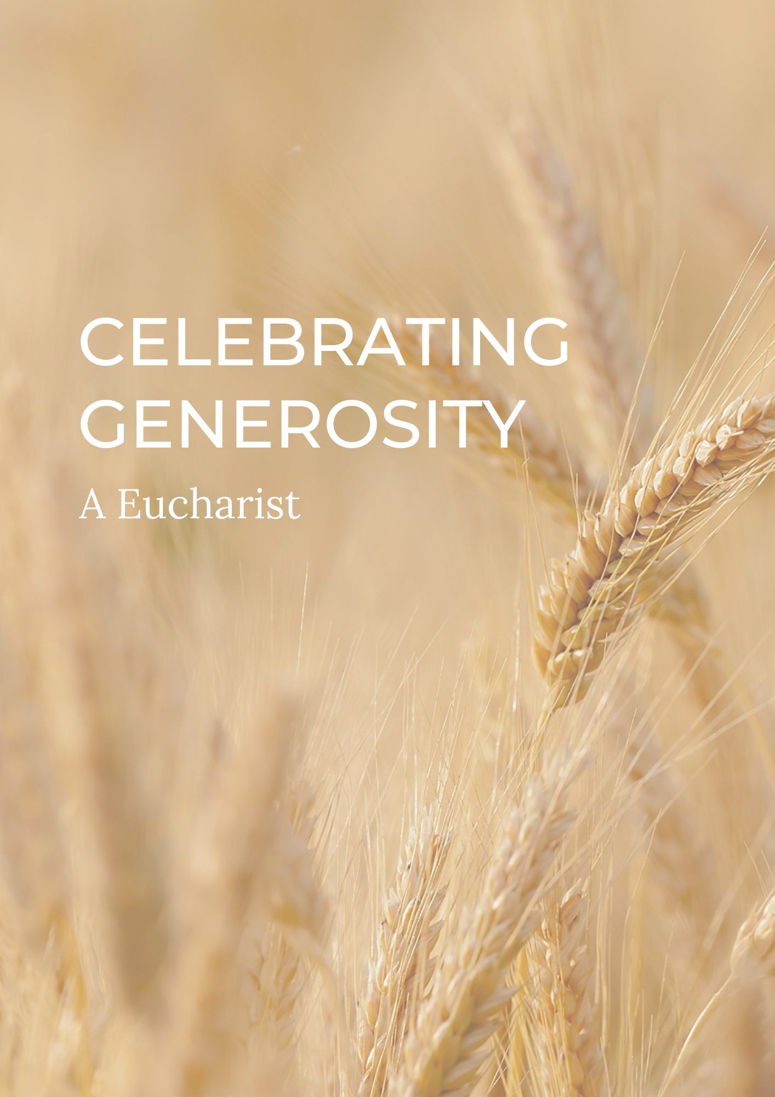

PREPARATION

In preparation for this act of worship, you might wish to pray privately this Ignatian Prayer for Generosity.

Lord, teach me to be generous.
Teach me to serve you as you deserve;
to give and not to count the cost,
to fight and not to heed the wounds,
to toil and not to seek for rest,
to labour and not to ask for reward,
save that of knowing that I do your will.
Amen. St Ignatius of Loyola

THE GATHERING

In the name of the Father,
and of the Son,
and of the Holy Spirit.
Amen.

God is able to provide us with every blessing in abundance,
so that by always having enough of everything,
we may share abundantly in every good work. cf. 2 Corinthians 9.8

Let everything be said and done in the name of the Lord Jesus,
giving thanks to God through Jesus Christ.
Let us bring our gifts to the Lord
that they may be used for his glory.
May the Spirit of God fill our hearts
as we come to meet him in this place.

Words of welcome or introduction may be said.
Prayers of Penitence

As those who know the generosity of God,
let us confess our sins,
especially the ways in which we take his good gifts for granted.

Father, in creation you are generous towards us,
yet we have sown sparingly;
Lord, have mercy.
Lord, have mercy.

Jesus, you show us the way of humility,
yet we have given reluctantly;
Christ, have mercy.
Christ, have mercy.

Holy Spirit, you show us the gift of grace,
yet we have loved grudgingly;
Lord, have mercy.
Lord, have mercy.

Almighty God,
who in Jesus Christ has given us
a kingdom that cannot be destroyed,
forgive us our sins,
open our eyes to God’s truth,
strengthen us to do God’s will
and give us the joy of his kingdom,
through Jesus Christ our Lord.
Amen.

Gloria in Excelsis

Gloria in excelsis may be used.

Glory to God in the highest,
and peace to his people on earth.
Lord God, heavenly King,
almighty God and Father,
we worship you, we give you thanks,
we praise you for your glory.
Lord Jesus Christ, only Son of the Father,
Lord God, Lamb of God,
you take away the sin of the world:
have mercy on us;
you are seated at the right hand of the Father:
receive our prayer.
For you alone are the Holy One,
you alone are the Lord,
you alone are the Most High, Jesus Christ,
with the Holy Spirit,
in the glory of God the Father. Amen.

The Collect

God of grace, ever creating and restoring,
you breathe life into all things
and embrace us with an everlasting love;
help us to grow in wonder and awe,
to embody a spirit of gratitude,
and to dream generous dreams;
that, in gathering what we have,
we may graciously offer ourselves
to accomplish what you will,
in Jesus Christ our Lord. Amen.
THE LITURGY OF THE WORD

The First Reading

The Book of Ruth chapters one and two.

Gospel Reading

Hear the Gospel of our Lord Jesus Christ, according to Luke.
Glory to you, O Lord.

As Jesus looked up, he saw the rich putting their gifts into the temple treasury. He also saw a poor widow put in two very small copper coins.

‘Truly I tell you,’ he said, ‘this poor widow has put in more than all the others. All these people gave their gifts out of their wealth; but she out of her poverty put in all she had to live on.’
Luke 21:1-4 (NIV)

This is the Gospel of the Lord.
Praise to you, O Christ.

A sermon may be given.

The Creed

We believe in one God,
the Father, the Almighty,
maker of heaven and earth,
of all that is,
seen and unseen.

We believe in one Lord, Jesus Christ,
the only Son of God,
eternally begotten of the Father,
God from God, Light from Light,
true God from true God,
begotten, not made,
of one Being with the Father;
through him all things were made.
For us and for our salvation he came down from heaven,
was incarnate from the Holy Spirit and the Virgin Mary
and was made man.
For our sake he was crucified under Pontius Pilate;
he suffered death and was buried.
On the third day he rose again
in accordance with the Scriptures;
he ascended into heaven
and is seated at the right hand of the Father.
He will come again in glory to judge the living and the dead,
and his kingdom will have no end.

We believe in the Holy Spirit,
the Lord, the giver of life,
who proceeds from the Father and the Son,
who with the Father and the Son is worshipped and glorified,
who has spoken through the prophets.
We believe in one holy catholic and apostolic Church.
We acknowledge one baptism for the forgiveness of sins.
We look for the resurrection of the dead,
and the life of the world to come.
Amen.

PRAYER

A Litany of Generosity

Let us give thanks to God
for his gifts so generous given to us,
and for the blessings we are called to share.

For recognising that all things come from you,
for remembering that we are stewards of your gifts,
for wisely using the resources entrusted to us.
We offer ourselves to you, O God.

For rejoicing in the beauty of creation,
for the care of your world,
for sharing the fruits of creation equally among all people.
We offer ourselves to you, O God.

For encountering the joy of giving,
for humility in putting others’ needs before our own,
for embracing the privilege of sharing in the ministry to the saints.
We offer ourselves to you, O God.

For courage in offering sacrificial generosity,
for giving to be an act of worship,
for grace in offering our souls and bodies to be a living sacrifice.
We offer ourselves to you, O God.

For all financial gifts offered to your Church,
for freely giving as we have received,
for giving and not counting the cost.
We offer ourselves to you, O God.

For releasing our hold on material possessions,
for contentment in what we have,
for trust in letting go.
We offer ourselves to you, O God.

For gathering the harvest,
for thankfulness in all you have given,
for reflecting on what you are calling us to create.
We offer ourselves to you, O God.

For generosity in love, encouragement and hope,
for openness in invitation and hospitality,
for wisdom in the gift of friendship.
We offer ourselves to you, O God.

For serving you as you deserve,
for following our calling as your disciples,
for serving you with gladness of heart.
We offer ourselves to you, O God.

For being a blessing through the blessings we receive,
for generosity which enables mission,
for sharing abundantly in every good work.
We offer ourselves to you, O God.

For living a generous life,
for our actions to point beyond themselves,
for our generosity to be an expression of love and gratitude.
We offer ourselves to you, O God.

Intercessions

Intercessions are offered, and may end with;

Source of all life and giver of all that is good,
hear our prayer,
and make us one in heart and mind
to serve you with joy forever. Amen.

THE LITURGY OF THE SACRAMENT

The Peace

The harvest of the Spirit is love, generosity, peace.
The peace of the Lord be always with you
and also with you.

All are invited to exchange a sign of peace.

An offering may be taken. There should be time for people to reflect on gifts given electronically. The table is prepared and bread and wine are placed upon it.

Prayer over the Offering

God of all creation,
the source of life and giver of all good things;
you have blessed us with all we have.
In our worship we bring now our first fruits:
gifts of gratitude, given in many ways.
With them we offer our lives.
Bless these gifts that they may be used to serve others,
to your praise and glory. Amen.
Taking of the Bread and Wine

Blessed are you, Lord God of all creation:
through your goodness we have this bread to set before you,
which earth has given and human hands have made.
It will become for us the bread of life.
Blessed be God for ever.

Blessed are you, Lord God of all creation:
through your goodness we have this wine to set before you,
fruit of the wine and work of human hands.
It will become for us the cup of salvation.
Blessed be God for ever.

The Eucharistic Prayer

The Lord be with you (or) The Lord is here.
and also with you. His Spirit is with us.
Lift up your hearts.
We lift them to the Lord.
Let us give thanks to the Lord our God.
It is right to give thanks and praise.

Eternal God and Father,
all things are in your making.
In fulfilment of your promise
you have showered us with blessings
and filled us with your gifts.
You form us in your image, the first fruits of your creation,
and by your Holy Spirit embed within us generous hearts
that we may be channels of your self-giving love.
Through your Son Jesus Christ,
you have freed us from our sins
and made us a kingdom of priests
to serve you with joy for ever.
Therefore with angels and archangels,
and with all the company of heaven,
we proclaim your great and glorious name,
for ever praising you and saying:

Holy, holy, holy Lord,
God of power and might,
heaven and earth are full of your glory.
Hosanna in the highest.
Blessed is he who comes in the name of the Lord.
Hosanna in the highest.

We praise and bless you, loving Father,
through Jesus Christ, our Lord;
and as we obey his command,
send your Holy Spirit,
that broken bread and wine outpoured
may be for us the body and blood of your dear Son.

On the night before he died he had supper with his friends
and, taking bread, he praised you.
He broke the bread, gave it to them and said:
Take, eat; this is my body which is given for you;
do this in remembrance of me.

When supper was ended he took the cup of wine.
Again he praised you, gave it to them and said:
Drink this, all of you;
this is my blood of the new covenant,
which is shed for you and for many for the forgiveness of sins.
Do this, as often as you drink it, in remembrance of me.

So, Father, we remember all that Jesus did,
in him we plead with confidence his sacrifice
made once for all upon the cross.
Bringing before you the bread of life and cup of salvation,
we proclaim his death and resurrection
until he comes in glory.

Praise to you, Lord Jesus:
Dying you destroyed our death,
rising you restored our life:
Lord Jesus, come in glory.

Lord of all life,
help us to work together for that day
when your kingdom comes
and justice and mercy will be seen in all the earth.

Look with favour on your people,
gather us in your loving arms
and bring us with [N and] all the saints
to feast at your table in heaven.
Through Christ, and with Christ, and in Christ,
in the unity of the Holy Spirit,
all honour and glory are yours, O loving Father,
for ever and ever.
Amen.

Offering ourselves into the hands of God,
as our Saviour taught us, so we pray
Our Father in heaven,
hallowed be your name,
your kingdom come,
your will be done,
on earth as in heaven.
Give us today our daily bread.
Forgive us our sins
as we forgive those who sin against us.
Lead us not into temptation
but deliver us from evil.
For the kingdom, the power,
and the glory are yours
now and for ever.
Amen.

We break this bread to share in the body of Christ.
Though we are many, we are one body,
because we all share in one bread.

(or)

O taste and see that the Lord is gracious;
blessed is the one who trusts in him.

God’s holy gifts
for God’s holy people.
Jesus Christ is holy,
Jesus Christ is Lord,
to the glory of God the Father.

Communion is administered.

Prayer after Communion

Loving and righteous God.
here at your table we have tasted your goodness and generosity
which exceeds all that we can desire or deserve;
liberate us from all jealousy and greed,
that we may respond cheerfully by offering ourselves,
and love and serve others to witness to your glory,
in the name of Jesus Christ our Lord.
Amen.

THE DISMISSAL

The God of hope fill us with every blessing,
that we may share in every good work;
and the blessing of God almighty,
the Father, the Son, and the Holy Spirit,
be among you and remain with you always.
Amen.

Go in peace to love and serve the Lord.
In the name of Christ. Amen.

Material in this order of service is taken from Common Worship, copyright © The Archbishops’ Council 2000-2006 and is used here with permission. www.commonworship.com. This order, with adapted offertory prayer, has been compiled by Sammi Tooze. This compilation is copyright © The National Giving Team 2020.

