A proposal for a new TEI for the North West

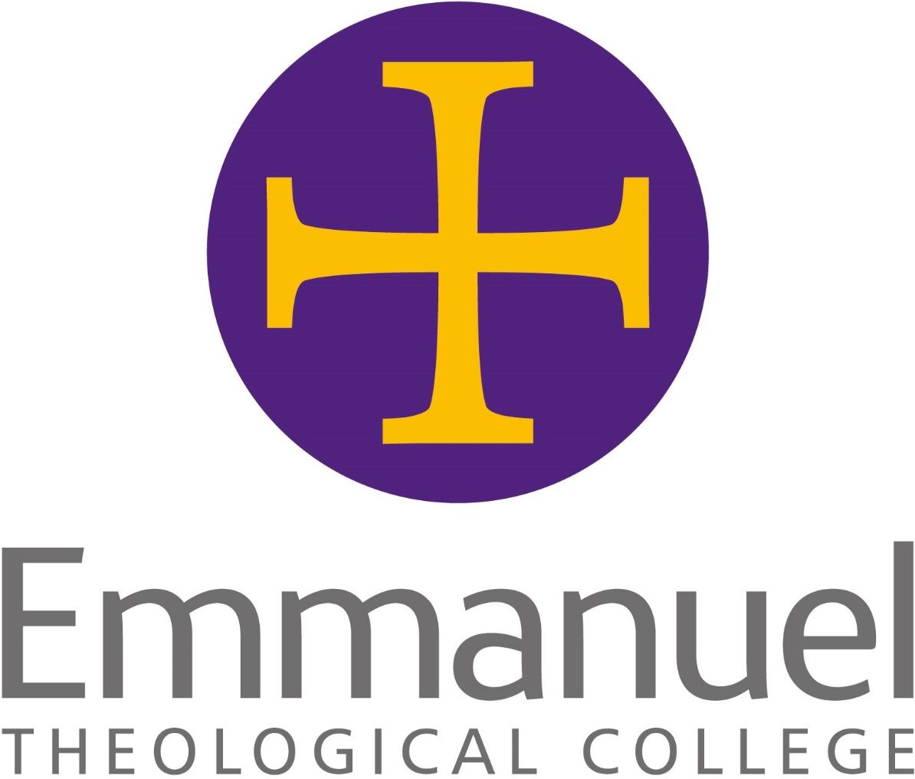

Rationale for the formation of a new TEI

Rationale for the creation of
Emmanuel Theological College
OCTOBER 2020 (UPDATED FEBRUARY 2021)

1. Background

1.1 The North West of England and the Isle of Man is home to over 7.4m people, with over 100,000 regular weekly attenders at over 1,500 churches supporting circa 830 benefices.

1.2 The thirteen Bishops of the North West are drawn from across the spectrum of traditions in the Church of England and live and work in communities that reflect the diverse socio-economic contexts of the region: from the hills of rural Cumbria to rolling plains of Cheshire, from the post-industrial heartlands and urban estates of East Lancashire to the modern cosmopolitan cities of Greater Manchester and Merseyside, the North West is in many ways a microcosm of the nation. However, in all of their diversity, the North West Bishops are united in their desire to see excellent contextual formation for ministry which prepares lay and ordained leaders from the region for Church in the region and beyond, with its potential benefits for the health of the whole Church.

1.3 In 2019 the North West Bishops commissioned Bishop Graham James to review theological training in the region. The Bishops were aware of some of the strengths of the current regional TEIs but were keen to understand what might be possible as they looked to the future. It must be stressed that the review was not commissioned because the three current TEIs (All Saints Centre for Mission and Ministry, Cumbrian Christian Learning and St Mellitus’ North West delivery centre) were failing. Indeed, Bishop Graham’s consultation found widespread satisfaction with the training offered by the existing three providers. Moreover, both All Saints and St Mellitus North West had had recent periodic external reviews (PER), and each received a positive outcome. Cumbria Christian Learning was due a PER in the coming year, but changes made under the leadership of a new Principal, and the fact that it was completing the process to become a wholly owned subsidiary of the Carlisle Diocese DBF, although small, put it in an equally strong position.

1.4 Over the period November 2019 to April 2020 Bishop Graham consulted widely with a significant number of key individuals in dioceses and theological education in producing his report to the North West Bishops (See Application Form Appendix 5). His review was supported by a detailed financial analysis by a forensic accountant which reassured the Bishops of the good financial health of the sector in the region.

1.5 At their meeting on 4th May 2020, the North West Bishops enthusiastically received Bishop Graham’s report and commissioned some further feasibility work ahead of a final decision at their 1st June 2020 meeting when they overwhelmingly accepted Bishop Graham’s recommendation that a single independent theological education institution be established to serve all the North West dioceses and that it should be functioning from the beginning of the academic year 2021/22.

1.6 An Implementation Group was therefore established by the North West Bishops, chaired by the Bishop of Burnley, supported by a small, part-time, staff team. The Implementation Group has a broad skills base and representation of dioceses, replicated in its two sub-committees (Academic and Staffing, chaired by the Bishop of Penrith; and Business and Finance, chaired by the Bishop of Warrington), and benefits from dedicated staff advisors from Ministry Team and the University of Durham. Staff from current TEIs and others have contributed to short term ‘task and finish’ groups which undertook discrete detailed work on behalf of the Implementation Group or its sub-committees to ensure the work to form the new College can be done efficiently and to a high standard.

1.7 With the gracious support of the All Saints Trustees, the decision was made to form the new college by repurposing the legal structures of All Saints. This decision made the formation of the new college more efficient and secure, not least because it provided the financial security of the substantial All Saints reserves. To ensure good governance and operational efficiency during the implementation phase, the All Saints Standing Committee has been incorporated into the Implementation Group.

1.8 Good progress has been made by the enlarged Implementation Group in the seven months since the initial announcement on 1st July. Alongside the successful completion of the Ministry Council processes for approval, a submission was made to the University of Durham Common Awards Team in late November and a validation visit in January 2021, with validation expected in April 2021. Work to obtain registration with the Office for Students has commenced, which when completed will enable students funded via government loans to study at Emmanuel. Most notably, The Revd Canon Dr Michael Leyden, previous Director of St Mellitus North West, was appointed as the Dean-elect of Emmanuel Theological College following a rigorous interview process on 7th August 2020. Michael has been playing an integral role in the shaping of every aspect of Emmanuel Theological College, and this has been made possible by St Mellitus generously releasing him to undertake this work on a phased basis across the autumn and spring terms.

2. Vision for Emmanuel Theological College

2.1 After prayerful consideration, wise counsel, and under the guidance of the Holy Spirit, the North West Bishops have caught a vision for a new independent integrated college incorporating the inherited richness of the current TEIs, and building on those riches to equip the whole people of God for the whole mission of God, with expectant aspirations for the transformation of the North West.

2.2 Emmanuel will recognise and build upon the learning already taking place amongst the people of God and in the lives of individual disciples. The ultimate vision is to offer not only formation for ministry for authorised and accredited lay and ordained leadership roles, but also equipping for the whole people of God in our churches and communities.

2.3 Included in this vision is a desire to see training that is
- thoroughly missional, seeing theological education as being caught up in God’s renewal of the whole of creation
- that is wholeheartedly communal in its attention to relationship with Christ as his disciples, with the whole of the worldwide the body of Christ, and with the wider creation
- and which is grounded in contextual practice, robust enough to both affirm and challenge the learner’s perspective
- accessible to all – regardless of age, economic status, gender, sexuality, ethnicity or disability
- Not just about theological education but is formational of the whole person as a disciple of Christ and a leader in the church and the world, developing in wisdom, maturity and holiness as well as knowledge and skills
- optimistic, flexible and creative in the way teaching, learning and formation happen in the contexts in which students live and minister

2.4 The college will offer part-time and full-time formational, vocational training for lay and ordained leaders of the Church and become the sole regional theological educational partner for the North West dioceses. The Bishops expect Emmanuel Theological College to be both an outstanding centre of excellence in theological education and be better able to respond to the rapidly changing needs of the Church across the region.

2.5 As part of responding to the needs of the region, Emmanuel will seek to offer training that is accessible to the people of the region and relevant to their live and ministries. The college will have an administrative centre close to Chester Cathedral and teaching centres for part-time students at Church House Penrith, Blackburn Cathedral, Nazarene College in Manchester and for full and part-time students at Liverpool Cathedral. In addition, where necessary, the college will develop specialist pathways for groups that have previously found it difficult to access training as there are many people who are called by God, but who currently find it hard to access the training they need.

2.6 While initially primarily focused on the core training provision for ordinands and trainee Readers/LLMs, Emmanuel will also welcome independent students onto its undergraduate and post-graduate programmes and offer a beginner’s theology access programme from the first year of operation. Thereafter, the College will work with the six North West dioceses to respond to their needs and gradually expand the range of programmes it offers to include youth work, CMD and contributions to IME2 for Readers/LLMs and clergy amongst others.

2.7 “We are praying that Emmanuel will engender faith, courage, hope and love in all who are formed within it. We are working collaboratively with all of our partners to ensure that this college is launched on time and on budget, and we have been greatly encouraged by the willingness of those we have engaged with to work with us as we seek to co-construct a Christ-centred, hope filled, mission orientated, formational community so that men and women can be equipped to share the good news of Jesus Christ across the region and beyond.”
Bishop of Burnley, Implementation Group Chair

2.8 That spirit of collaboration is evident in the theological diversity of the Implementation Group and the diversity of tradition in the wider team of North West Bishops who are supporting this project. In establishing Emmanuel Theological College, mutual flourishing is being embodied by the different traditions of the Church working together as a visible, tangible sign of what is possible when Christians come together in missional unity.

3. The name: Emmanuel Theological College

3.1 Settling on the name, ‘Emmanuel Theological College’, was a process of careful discernment. The Bishops considered a range of options but were excited by the simple, faithful claim of ‘Emmanuel’, God with us: God with us across the North West in every place and community. It is testimony to what we see every day – the Lord Jesus at work bringing hope in everyday lives, building up his Church, and expanding his Kingdom for the transformation of our communities. We believe that Emmanuel Theological College is part of that work of God in this region and in our nation.

3.2 The use of the name Emmanuel is surprisingly uncommon and Emmanuel Theological College is almost unique around the world. There was a non-conformist theological college called ‘Emmanuel College’ in Birkenhead which closed in 1997 by merging with the Nazarene Theological College in Didsbury, Manchester where there is an Emmanuel library and classroom block. It is therefore a source of particular joy that the Nazarene Theological College is working with the Implementation Team to explore opportunities for partnership with the new college including using their facilities for the Manchester Teaching Centre.

4. Support for Emmanuel Theological College

4.1 The North West Bishops remain actively committed to the creation and flourishing of Emmanuel Theological College.
Other key stakeholders who have been engaged supportively in the project so far include:
- The six North West Diocesan Secretaries, DBF Chairs, Bishop’s Leadership Teams and Bishop’s Councils
- The All Saints Centre for Mission and Ministry Trustees
  - Gracious commitment of their reserves and their legal structures
  - Active partnership with the Standing Committee in the Implementation Group
  - Generous access to staff time supported by the Principal
  - Letter of support from the Chair available in Appendix 6 of the main Application Form
- Cumbria Christian Learning
  - Active engagement and support from the Principal
  - Letter of support from the Chair available in Appendix 6 of the main Application Form
- St Mellitus College
  - generously positive public statement after 1st July announcement
  - there has been one formal interface meeting between representatives of Implementation Group and St Mellitus College, together with the Bishops of Manchester and Blackburn
  - the Dean of St Mellitus, Michael Leyden and the Emmanuel Project Director now hold regular conversations to enable a smooth transition
  - generous releasing of Michael Leyden to support the development of Emmanuel in the current academic year
- Positive response from staff and existing students of all three existing TEIs via social media and on-line engagement sessions with members of the Implementation Group.
- Active real-time advice from Ministry Team and the Common Awards team to help co-construct an outstanding TEI.

5. Governance of Emmanuel Theological College

5.1 As a result of the generous support of the All Saints Trustees, Emmanuel Theological College will have a legal basis formed from the Articles of Association of All Saints Centre for Mission and Ministry. However, every aspect of the current Articles of Association has been reviewed and is being substantially altered:

- The Diocesan Boards of Finance and the Diocesan Bishops of the six North West dioceses will be the Members
- The Diocesan Bishops will collectively appoint twelve trustees
- Trustees will be appointed based on their skills, with close attention paid to all forms of diversity and it will be normal for each diocese to provide at least one Trustee
- The Trustees can co-opt up to four other Trustees if they deem it necessary to acquire additional skills or representation
- The Chair of Trustees will always be a Bishop serving in the region and will be appointed by the six Diocesan Bishops
- The Vice-Chair of Trustees will be a lay person appointed by the Board of Trustees
- No Trustee can serve more than three terms of three years each before having a fallow year

5.2 The Diocesan Bishops have already appointed the Bishop of Chester as the first Chair of Trustees and identified an initial skills-based diversity-balanced Board of Trustees and four potential co-optees.

5.3 Moreover, the relationship between Dean of Emmanuel Theological College and the North West Bishops is a crucial one and therefore the Dean will customarily attend meetings of the North West Bishops to discuss matters related to the TEI, theological education more broadly in the region and to take soundings on plans for development.

6. Finances and Business Case

6.1 The history of the TEI sector has too many examples of colleges and courses which get into financial difficulties and the North West Bishops are determined that Emmanuel Theological College will have solid finances. As such the financial analysis for Emmanuel has been prepared on a conservative basis to reflect only the core initial operations of the College. Growth into other forms of training (e.g. youth work, IME2, CMD) will all provide a larger student base and associated income stream with low marginal increase in costs.

6.2 Students are the only budgeted income stream and come in three forms: Ordinands, Readers/LLMs and Independent Students
- Ordinand numbers are based on five-year averages for the actual pathways (including pathway duration) for the five English North West dioceses at the three current providers, i.e. excluding Sodor & Man.
- Reader/LLM numbers are 80% of historical averages for the English dioceses excluding Chester who currently train Readers on a diocesan programme. The forecast of Reader/LLMs is more conservative that ordinands due to the greater variability in Reader/LLM vocations year to year.
- Independent students are initially 50% of recent St Mellitus North West numbers, rising over three years to 100% of recent St Mellitus North West numbers.

6.3 Similarly, cost been conservatively budgeted for, based on the projected staff team together with a combination of scaled actual incurred costs of the current TEIs operating in the region and estimates and quotations from suppliers where available. To make the budget more robust a contingency of 10% of all expenditure has been assumed for the first five years.

6.4 On this basis Emmanuel would operate at a modest deficit of £61k in 2021/22 but this would be drawn from the c.£400k of All Saints reserves carried over to Emmanuel and includes repaying start-up loans of £60k from the six diocesan boards of finance. Thereafter, the college is projected to make modest surpluses of 1-4% of income per annum. Given this is on a conservative income and expenditure basis, Emmanuel Theological College represents a solid business case, with low fixed costs and flexibility to meet future needs of the Church in the region.

7. Staffing

7.1 The North West Bishops have been clear that Emmanuel Theological College must deliver outstanding training to lay and ordained leaders of all backgrounds across the region. This will only be possible if the college appoints an outstanding staff team.

7.2 As stated previously, The Revd Canon Dr Michael Leyden has been appointed at Dean-elect of Emmanuel. Michael brings with him fourteen years of experience in higher education, most of which has been within Anglican theological colleges. His experience as a key leader in the founding and flourishing of St Mellitus North West will be invaluable in the establishment of Emmanuel as a high quality training intuition. Michael will be joining Emmanuel full-time at Dean for the Easter term.

7.3 The staff appointment processes are coming to a conclusion resulting in an academic staff team of Tutors in Theology covering eleven core specialisms (Apologetics, Church History, Doctrine (including Sacramental Theology), Ethics, Homiletics, Liturgy, Missiology/Pioneer Ministry, New Testament Greek, New Testament, Old Testament and Pastoral Ministry). Tutors in Theology will also lead student formation groups, but they may be supplemented by some additional Formation Tutors where necessary, the number of which will vary depending on the size of the student body.

7.4 The teaching and formation staff team will be supported by a team of occasional Visiting Lecturers and Chaplains together with a strong central staff administration team, Academic Support and Postgraduate Tutors and a college wide Leadership Team. The Leadership Team includes a Centre Leader for each of the four delivery centres across the region together with the Dean, Vice-Dean and Academic Registrar. Centre Leaders will also be either teaching or formation tutors with additional responsibilities for local oversight of delivery centres, primarily in coordination of facilities but also in pastoral support and monitoring the quality of the student experience.

7.5 Staff are initially being recruited from the existing three providers operating in the region, with any vacancies recruited externally to ensure the outstanding and diverse formational experience which lies at the heart of the vision for Emmanuel Theological College.

“This is no easy task, but I believe that God’s timing is good.
‘When the time is right, I, the Lord, will make it happen.’ (Isaiah 60.22).
The Lord always uses his faithful servants and I am sure that in the North West region many stand ready for a lead into a new and confident era in preparing men and women for mission and ministry in God’s Church”.
Bishop Graham James

