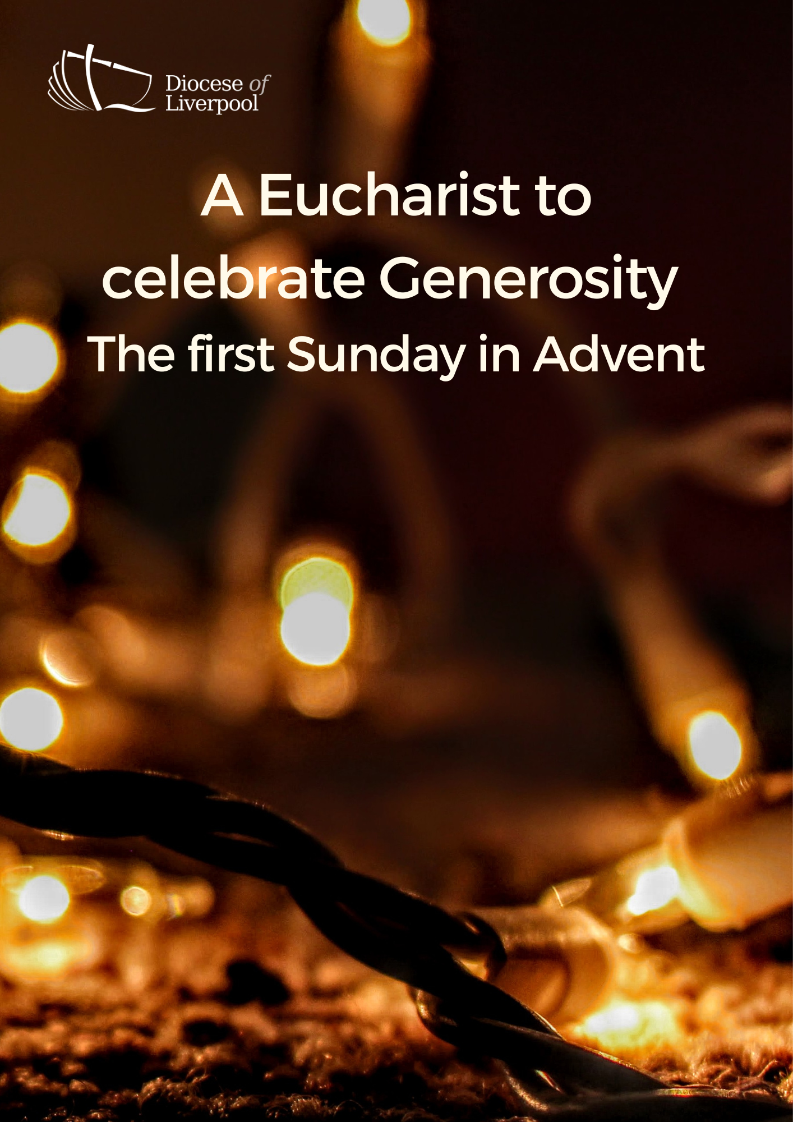

PREPARATION

In preparation for this act of worship, you might wish to pray privately this Ignatian Prayer for Generosity.

Lord, teach me to be generous.
Teach me to serve you as you deserve;
to give and not to count the cost,
to fight and not to heed the wounds,
to toil and not to seek for rest,
to labour and not to ask for reward,
save that of knowing that I do your will.
Amen.
St Ignatius of Loyola

THE GATHERING

In the name of the Father,
and of the Son,
and of the Holy Spirit. Amen.

The Lord is my light and my salvation.
The Lord is my light and my salvation.
With you, O Lord, is the well of life:
In your light shall we see light.
Your word is a lantern to my feet
and a light upon our path.

Blessed are you, Lord our God, King of the universe,
eternal creator of light and darkness.
In this season of Advent,
when the sun's light is swallowed up
by the growing darkness of night,
you renew your promise to reveal among us
the splendour of your glory,
in the gift of Jesus Christ your Son.
Through the prophets
you teach us to hope for his reign of peace.
Through the outpouring of his Spirit,
you open our hearts to live more generously.
Strengthen us as we seek to grow in your likeness,
and free our hearts in gratitude to sing your praise:
for to you all honour and blessing are due,
now and for ever. Amen.

The lighting of the Advent candle

Blessed are you, God of Abraham and Sarah,
and all the patriarchs of old.
Your love is revealed to us in Jesus Christ,
Son of God and Son of David.
Give us thankful hearts as we prepare to celebrate his birth
and make our hearts ready
to welcome your generous Spirit to dwell among us.
Make us one as we walk with Christ
today and for ever. Amen

Prayers of Penitence

As we prepare to receive the gift of the infant Christ,
we remember the times when we have not received graciously,
or lived in the light of our generous God.

Father, you give to us your Son,
yet we receive grudgingly;
Lord, have mercy.
Lord, have mercy.

Jesus, you made yourself poor, that we might become rich,
yet we hoard our possessions and forget to live by your example;
Christ, have mercy.
Christ, have mercy.

Holy Spirit, you bless us with the fruit of generosity,
yet we fail to respond to your call;
Lord, have mercy.
Lord, have mercy.

May the God of all healing and forgiveness
draw us to himself and cleanse us from all our sins,
that we may behold the glory of his Son,
Jesus Christ our Lord.
Amen.

The Collect

Almighty God,
give us grace to cast away the works of darkness
and to put on the armour of light,
now in the time of this mortal life,
in which your Son Jesus Christ came to us in great humility;
that on the last day,
when he shall come again in his glorious majesty
to judge the living and the dead,
we may rise to the life immortal;
through him who is alive and reigns with you,
in the unity of the Holy Spirit,
one God, now and for ever.

A children's talk or an all age activity may take place at this point

THE LITURGY OF THE WORD
The First Reading
On the twenty-first day of the seventh month, the word of the Lord came through the prophet Haggai: “Speak to Zerubbabel son of Shealtiel, governor of Judah, to Joshua son of Jozadak, the high priest, and to the remnant of the people. Ask them, ‘Who of you is left who saw this house in its former glory? How does it look to you now? Does it not seem to you like nothing? But now be strong, Zerubbabel,’ declares the Lord. ‘Be strong, Joshua son of Jozadak, the high priest. Be strong, all you people of the land,’ declares the Lord, ‘and work. For I am with you,’ declares the Lord Almighty. ‘This is what I covenanted with you when you came out of Egypt. And my Spirit remains among you. Do not fear.’
“This is what the Lord Almighty says: ‘In a little while I will once more shake the heavens and the earth, the sea and the dry land. I will shake all nations, and what is desired by all nations will come, and I will fill this house with glory,’ says the Lord Almighty. ‘The silver is mine and the gold is mine,’ declares the Lord Almighty. ‘The glory of this present house will be greater than the glory of the former house,’ says the Lord Almighty. ‘And in this place I will grant peace,’ declares the Lord Almighty.”
Now give careful thought to this from this day on – consider how things were before one stone was laid on another in the Lord’s temple. When anyone came to a heap of twenty measures, there were only ten. When anyone went to a wine vat to draw fifty measures, there were only twenty. I struck all the work of your hands with blight, mildew and hail, yet you did not return to me,” declares the Lord. “From this day on, from this twenty-fourth day of the ninth month, give careful thought to the day when the foundation of the Lord’s temple was laid. Give careful thought: is there yet any seed left in the barn? Until now, the vine and the fig-tree, the pomegranate and the olive tree have not borne fruit. ‘“From this day on I will bless you.”’
Haggai 2:1-9; 15-19
This is the Word of the Lord.
Thanks be to God.
Gospel Reading
Hear the Gospel of our Lord Jesus Christ, according to Mark.
Glory to you, O Lord.

But in those days, following that distress,
“the sun will be darkened,
and the moon will not give its light;
the stars will fall from the sky,
and the heavenly bodies will be shaken.”
At that time people will see the Son of Man coming in clouds with great power and glory. And he will send his angels and gather his elect from the four winds, from the ends of the earth to the ends of the heavens.
Now learn this lesson from the fig-tree: as soon as its twigs get tender and its leaves come out, you know that summer is near. Even so, when you see these things happening, you know that it is near, right at the door. Truly I tell you, this generation will certainly not pass away until all these things have happened. Heaven and earth will pass away, but my words will never pass away.
But about that day or hour no one knows, not even the angels in heaven, nor the Son, but only the Father. Be on guard! Be alert! You do not know when that time will come. It’s like a man going away: he leaves his house and puts his servants in charge, each with their assigned task, and tells the one at the door to keep watch. Therefore keep watch because you do not know when the owner of the house will come back – whether in the evening, or at midnight, or when the cock crows, or at dawn. If he comes suddenly, do not let him find you sleeping. What I say to you, I say to everyone: “Watch!”’
Mark 13:24-37
This is the Gospel of the Lord.
Praise to you, O Christ.

The sermon
The Creed
We believe in one God, the Father, the Almighty,
maker of heaven and earth, of all that is, seen and unseen.

We believe in one Lord, Jesus Christ,
the only Son of God,
eternally begotten of the Father,
God from God, Light from Light,
true God from true God,
begotten, not made,
of one Being with the Father;
through him all things were made.
For us and for our salvation he came down from heaven,
was incarnate from the Holy Spirit and the Virgin Mary
and was made man.
For our sake he was crucified under Pontius Pilate;
he suffered death and was buried.
On the third day he rose again
in accordance with the Scriptures;
he ascended into heaven
and is seated at the right hand of the Father.
He will come again in glory to judge the living and the dead,
and his kingdom will have no end.

We believe in the Holy Spirit,
the Lord, the giver of life,
who proceeds from the Father and the Son,
who with the Father and the Son is worshipped and glorified,
who has spoken through the prophets.
We believe in one holy catholic and apostolic Church.
We acknowledge one baptism for the forgiveness of sins.
We look for the resurrection of the dead,
and the life of the world to come. Amen.
PRAYER

In joyful expectation of the gift of the Infant Christ,
we pray to Jesus saying;
Maranatha.
Come, Lord Jesus.

Come to your Church as Lord and judge.
We pray for our local community In this parish,
that we might bless those around us this Advent with joy and grace.
Help us to live In the light of your coming
and giving us a longing for your kingdom.
Maranatha.
Come, Lord Jesus.

Come to your world as King of the nations.
We pray for those who lead and govern this country,
that they might take courage from generosity In their relationships,
and lead with humility.
Before you rulers will stand In silence.
Maranatha.
Come, Lord Jesus.

Come to the suffering as Saviour and comforter.
We pray for your gift of peace,
and for the spirit of receiving graciously when we are In need.
Break into those areas of our lives
where we struggle with sickness and distress,
and set us free to serve you for ever.
Maranatha.
Come, Lord Jesus.

Come to us from heaven with power and great glory.
Lift us up to meet you,
that with all your saints and angels
we may live and reign with you In your new creation.
Maranatha.
Come, Lord Jesus.

Silence is kept.

Source of all life and giver of all that is good,
give to your people who trust in your love
a spirit of joy in generosity.
By your coming, raise us to share in the joy of your kingdom
on earth as in heaven,
and make us one in heart and mind
to serve you with joy forever.
Amen.

THE LITURGY OF THE SACRAMENT
The Peace

May the God of peace give you the gift of holiness,
ready for the coming of our Lord Jesus Christ.
The peace of the Lord be always with you
and also with you.

All are invited to exchange a sign of peace.

An offering is received, giving time for people to reflect on gifts given electronically. The table is prepared and bread and wine are placed upon it.
Prayer over the Offering

God of all creation,
the source of life and giver of all good things;
through your goodness you have blessed us with all we have.
We bring before you these gifts of gratitude, given in many ways.
With them we offer our lives;
that we may be used to serve others,
and give you glory.
We make our prayer
in the name of Jesus Christ,
who is the perfect gift incarnate.
Amen.

Taking of the Bread and Wine

Blessed are you, Lord God of abundance:
through your goodness we have this bread to set before you,
which earth has given and human hands have made.
It will become for us the bread of life.
Blessed be God for ever.

Blessed are you, Lord God of abundance:
through your goodness we have this wine to set before you,
fruit of the wine and work of human hands.
It will become for us the cup of salvation.
Blessed be God for ever.

The Eucharistic Prayer

The Lord be with you (or) The Lord is here.
and also with you. His Spirit is with us.
Lift up your hearts.
We lift them to the Lord.
Let us give thanks to the Lord our God.
It is right to give thanks and praise.

It is indeed right and good to give you thanks and praise,
almighty God and everlasting Father,
through Jesus Christ your Son.
For when he humbled himself to come among us in human flesh,
he modelled the true spirit of generosity and self-giving love.

Confident that your promise will be fulfilled,
we now watch for the day
when Christ our Lord will come again in glory.
And so we join our voices with angels and archangels
and with the whole company of heaven
to proclaim your glory,
for ever praising you and saying:

Holy, holy, holy Lord,
God of power and might,
heaven and earth are full of your glory.
Hosanna in the highest.
Blessed is he who comes in the name of the Lord.
Hosanna in the highest.

We praise and bless you, loving Father,
through Jesus Christ, our Lord;
and as we obey his command,
send your Holy Spirit,
that broken bread and wine outpoured
may be for us the body and blood of your dear Son.

On the night before he died he had supper with his friends
and, taking bread, he praised you.
He broke the bread, gave it to them and said:
Take, eat; this is my body which is given for you;
do this in remembrance of me.

When supper was ended he took the cup of wine.
Again he praised you, gave it to them and said:
Drink this, all of you;
this is my blood of the new covenant,
which is shed for you and for many for the forgiveness of sins.
Do this, as often as you drink it, in remembrance of me.

So, Father, we remember all that Jesus did,
in him we plead with confidence his sacrifice
made once for all upon the cross.
Bringing before you the bread of life and cup of salvation,
we proclaim his death and resurrection
until he comes in glory.

Praise to you, Lord Jesus:
Dying you destroyed our death,
rising you restored our life:
Lord Jesus, come in glory.

Lord of all life,
help us to work together for that day
when your kingdom comes
and justice and mercy will be seen in all the earth.

Look with favour on your people,
gather us in your loving arms
and bring us with [N and] all the saints
to feast at your table in heaven.
Through Christ, and with Christ, and in Christ,
in the unity of the Holy Spirit,
all honour and glory are yours, O loving Father,
for ever and ever.
Amen.

Rejoicing in the gift of his presence among us,
as our Saviour taught us, so we pray
Our Father in heaven,
hallowed be your name,
your kingdom come,
your will be done,
on earth as in heaven.
Give us today our daily bread.
Forgive us our sins
as we forgive those who sin against us.
Lead us not into temptation
but deliver us from evil.
For the kingdom, the power,
and the glory are yours
now and for ever.
Amen.

We break this bread to share in the body of Christ.
Though we are many, we are one body,
because we all share in one bread.

(or)

O taste and see that the Lord is gracious;
blessed is the one who trusts in him.

God’s holy gifts
for God’s holy people.
Jesus Christ is holy,
Jesus Christ is Lord,
to the glory of God the Father.

Communion is administered.

Prayer after Communion

Generous God,
you have fed us at your heavenly table.
Kindle us with the fire of your Spirit
that when Christ comes again in glory
we may shine like lights before him
and witness to his self-giving love;
who is alive and reigns with you and the Holy Spirit,
one God, now and for ever.
Amen.

THE DISMISSAL

May Christ, who for our sake became poor
make you rich in everything -
in faith, generosity, grace and love;
and the blessing of God almighty,
the Father, the Son, and the Holy Spirit,
be among you and remain with you always.
Amen.

Go in peace to love and serve the Lord.
In the name of Christ. Amen.

Material in this order of service is taken from Common Worship, copyright © The Archbishops’ Council 2000-2006 and is used here with permission. www.commonworship.com. This order has been compiled by Sammi Tooze.

