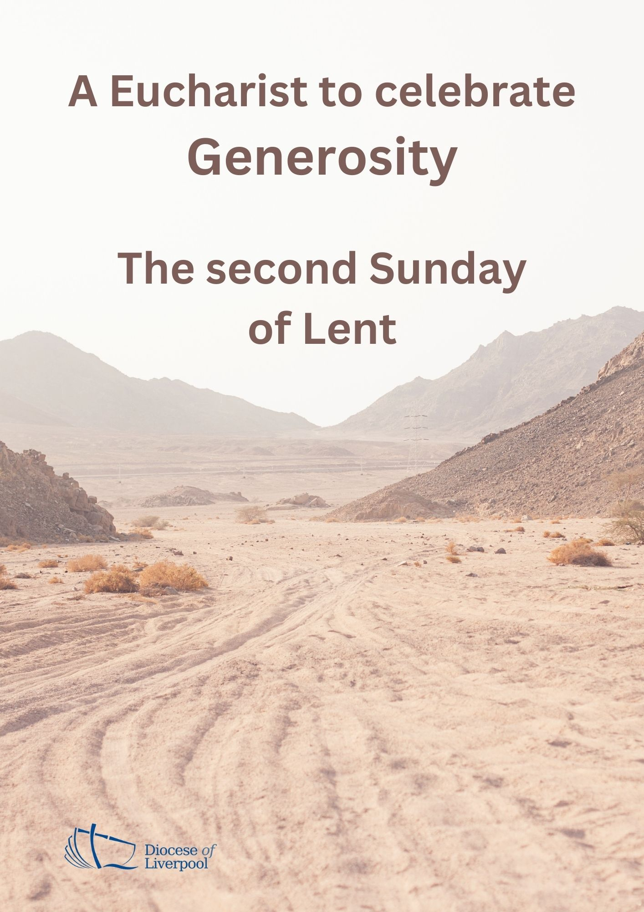

PREPARATION

In preparation for this act of worship, you might wish to pray privately this Ignatian Prayer for Generosity.

Lord, teach me to be generous.
Teach me to serve you as you deserve;
to give and not to count the cost,
to fight and not to heed the wounds,
to toil and not to seek for rest,
to labour and not to ask for reward,
save that of knowing that I do your will.
Amen.
St Ignatius of Loyola

THE GATHERING

In the name of the Father,
and of the Son,
and of the Holy Spirit. Amen.

God is able to provide us with every blessing in abundance,
so that by always having enough of everything,
we may share abundantly in every good work. ( 2 Corinthians 9.8)

Let everything be said and done in the name of the Lord Jesus,
giving thanks to God through Jesus Christ.
Let us bring our gifts to the Lord
that they may be used for his glory.
May the Spirit of God fill our hearts
as we come to meet him in this place.

Prayers of Penitence

As we journey together through the obedience of Lent,
we remember the times when we have not received gratefully and gladly
or shared generously and graciously of all our generous God has given to us.

Father, you give to us your Son,
yet we receive grudgingly;
Lord, have mercy.
Lord, have mercy.

Jesus, you made yourself poor, that we might become rich,
yet we hoard our possessions and forget to live by your example;
Christ, have mercy.
Christ, have mercy.
Holy Spirit, you bless us with the fruit of generosity,
yet we fail to respond to your call;
Lord, have mercy.
Lord, have mercy.

May the God of all healing and forgiveness
draw us to himself and cleanse us from all our sins,
that we may behold the glory of his Son,
Jesus Christ our Lord.
Amen.

The Collect
Almighty God,
by the prayer and discipline of Lent
may we enter into the mystery of Christ’s sufferings,
and by following in his Way
come to share in his glory;
through Jesus Christ our Lord. Amen

A prayer for generous discipleship
O God,
help us, this day, to be
open to your generous gift of love,
to share our faith with willingness,
to delight in the beauty of your creation,
to seek you out in the people we meet,
to know you in the quietness,
to sense you in the busyness.
This we pray in the name of Jesus. Amen. (Church in Wales)

A children's talk or an all age activity may take place at this point
THE LITURGY OF THE WORD
The First Reading
Remember this: whoever sows sparingly will also reap sparingly, and whoever sows generously will also reap generously. Each of you should give what you have decided in your heart to give, not reluctantly or under compulsion, for God loves a cheerful giver.
And God is able to bless you abundantly, so that in all things at all times, having all that you need, you will abound in every good work.
Now he who supplies seed to the sower and bread for food will also supply and increase your store of seed and will enlarge the harvest of your righteousness. You will be enriched in every way so that you can be generous on every occasion, and through us your generosity will result in thanksgiving to God.
This service that you perform is not only supplying the needs of the Lord’s people but is also overflowing in many expressions of thanks to God.
2 Cor 9:6-8, 10-12
This is the Word of the Lord.
Thanks be to God.
Gospel Reading

Hear the Gospel of our Lord Jesus Christ, according to Mark.
Glory to you, O Lord.

The apostles gathered round Jesus and reported to him all they had done and taught. Then, because so many people were coming and going that they did not even have a chance to eat, he said to them, ‘Come with me by yourselves to a quiet place and get some rest.’

So they went away by themselves in a boat to a solitary place. But many who saw them leaving recognised them and ran on foot from all the towns and got there ahead of them. When Jesus landed and saw a large crowd, he had compassion on them, because they were like sheep without a shepherd. So he began teaching them many things.

By this time it was late in the day, so his disciples came to him. ‘This is a remote place,’ they said, ‘and it’s already very late. Send the people away so that they can go to the surrounding countryside and villages and buy themselves something to eat.’ But he answered, ‘You give them something to eat.’

They said to him, ‘That would take more than half a year’s wages! Are we to go and spend that much on bread and give it to them to eat?’ ‘How many loaves do you have?’ he asked. ‘Go and see.’ When they found out, they said, ‘Five – and two fish.’
Then Jesus told them to make all the people sit down in groups on the green grass. So they sat down in groups of hundreds and fifties. Taking the five loaves and the two fish and looking up to heaven, he gave thanks and broke the loaves. Then he gave them to his disciples to distribute to the people. He also divided the two fish among them all. They all ate and were satisfied, and the disciples picked up twelve basketfuls of broken pieces of bread and fish.
Mark 6: 30-43
This is the Gospel of the Lord.
Praise to you, O Christ.

The sermon
The Creed
We believe in one God, the Father, the Almighty,
maker of heaven and earth, of all that is, seen and unseen.

We believe in one Lord, Jesus Christ,
the only Son of God,
eternally begotten of the Father,
God from God, Light from Light,
true God from true God,
begotten, not made,
of one Being with the Father;
through him all things were made.
For us and for our salvation he came down from heaven,
was incarnate from the Holy Spirit and the Virgin Mary
and was made man.
For our sake he was crucified under Pontius Pilate;
he suffered death and was buried.
On the third day he rose again
in accordance with the Scriptures;
he ascended into heaven
and is seated at the right hand of the Father.
He will come again in glory to judge the living and the dead,
and his kingdom will have no end.

We believe in the Holy Spirit,
the Lord, the giver of life,
who proceeds from the Father and the Son,
who with the Father and the Son is worshipped and glorified,
who has spoken through the prophets.
We believe in one holy catholic and apostolic Church.
We acknowledge one baptism for the forgiveness of sins.
We look for the resurrection of the dead,
and the life of the world to come. Amen.
PRAYERS

Let us pray to God who is generous and compassionate.
Lord hear us, Lord graciously hear us.
Lord Jesus, you look upon your people with compassion.
We pray for all who lead your church and seek first your kingdom.
Especially we pray for…
Let us pray to God who is generous and compassionate.
Lord hear us, Lord graciously hear us.
Lord Jesus you look upon your world with compassion.
We pray for the leaders of the world, that stirred by the Holy Spirit they may be filled with concern, seeking justice and truth.
Especially we pray for…
Let us pray to God who is generous and compassionate.
Lord hear us, Lord graciously hear us.
Lord Jesus the disciples, stirred by your words, cared for and ministered to others. We pray for our community as we seek to serve and to share your love. Especially we pray for…
Let us pray to God who is generous and compassionate.
Lord hear us, Lord graciously hear us.
Lord Jesus look with loving care and compassion on all who suffer in body, mind or spirit and on all those who grieve the loss of a loved one. By your healing power bring wholeness and hope. Especially we pray for ….
Let us pray to God who is generous and compassionate.
Lord hear us, Lord graciously hear us.
Generous and compassionate God,
accept our prayers
and stir in us a generosity of spirit that comes from you.
Amen. (Giving in Grace: adapted)

THE LITURGY OF THE SACRAMENT
The Peace
May we be made strong, enduring everything with patience
while joyfully giving thanks to the Father,
who has enabled us to share in the inheritance of the saints in the light. (cf. Col 1.11-12)

The peace of the Lord be always with you
and also with you.

All are invited to exchange a sign of peace.
An offering is received, giving time for people to reflect on gifts given electronically. The table is prepared and bread and wine are placed upon it.

Prayer over the Offering
God of all creation,
the source of life and giver of all good things;
through your goodness you have blessed us with all we have.
We bring before you these gifts of gratitude, given in many ways.
With them we offer our lives;
that we may be used to serve others,
and give you glory. Amen.

Taking of the Bread and Wine
Giving God,
from whom comes every good and perfect gift,
that we might grow in gratitude and share your blessings;
accept these gifts of bread and wine,
and may the sacrifice of Christ draw us closer to you;
through Jesus Christ our Lord. Amen.
The Eucharistic Prayer

The Lord be with you (or) The Lord is here.
and also with you. His Spirit is with us.
Lift up your hearts.
We lift them to the Lord.
Let us give thanks to the Lord our God.
It is right to give thanks and praise.

It is indeed right and good
to give you thanks and praise,
almighty God and everlasting Father,
through Jesus Christ your Son.
For in these forty days
you lead us into the desert of repentance
that through a pilgrimage of prayer and discipline
we may grow in grace
and learn to be your people once again.

Through fasting, prayer and acts of service
you bring us back to your generous heart.
Through study of your holy word
you open our eyes to your presence in the world
and free our hands to welcome others
into the radiant splendour of your love.

As we prepare to celebrate the Easter feast
with joyful hearts and minds
we bless you for your mercy
and join with saints and angels
for ever praising you and saying:

Holy, holy, holy Lord,
God of power and might,
heaven and earth are full of your glory.
Hosanna in the highest.
Blessed is he who comes in the name of the Lord.
Hosanna in the highest.

We praise and bless you, loving Father,
through Jesus Christ, our Lord;
and as we obey his command,
send your Holy Spirit,
that broken bread and wine outpoured
may be for us the body and blood of your dear Son.

On the night before he died he had supper with his friends
and, taking bread, he praised you.
He broke the bread, gave it to them and said:
Take, eat; this is my body which is given for you;
do this in remembrance of me.

When supper was ended he took the cup of wine.
Again he praised you, gave it to them and said:
Drink this, all of you;
this is my blood of the new covenant,
which is shed for you and for many for the forgiveness of sins.
Do this, as often as you drink it, in remembrance of me.

So, Father, we remember all that Jesus did,
in him we plead with confidence his sacrifice
made once for all upon the cross.
Bringing before you the bread of life and cup of salvation,
we proclaim his death and resurrection
until he comes in glory.

Praise to you, Lord Jesus:
Dying you destroyed our death,
rising you restored our life:
Lord Jesus, come in glory.

Lord of all life,
help us to work together for that day
when your kingdom comes
and justice and mercy will be seen in all the earth.

Look with favour on your people,
gather us in your loving arms
and bring us with [N and] all the saints
to feast at your table in heaven.
Through Christ, and with Christ, and in Christ,
in the unity of the Holy Spirit,
all honour and glory are yours, O loving Father,
for ever and ever.
Amen.

Rejoicing in the gift of his presence among us,
as our Saviour taught us, so we pray
Our Father in heaven,
hallowed be your name,
your kingdom come,
your will be done,
on earth as in heaven.
Give us today our daily bread.
Forgive us our sins
as we forgive those who sin against us.
Lead us not into temptation
but deliver us from evil.
For the kingdom, the power,
and the glory are yours
now and for ever. Amen.
We break this bread to share in the body of Christ.
Though we are many, we are one body,
because we all share in one bread.

(or)

O taste and see that the Lord is gracious;
blessed is the one who trusts in him.

God’s holy gifts
for God’s holy people.
Jesus Christ is holy,
Jesus Christ is Lord,
to the glory of God the Father.

Communion is administered.

Prayer after Communion

Gracious God,
around your table we taste your generosity and your sacrificial love;
help us to be rooted, grafted and built in you,
that in all we are and all we do,
we may show forth abundant thanksgiving,
live lives of immeasurable gratitude,
and excel in the grace of giving;
through Jesus Christ our Lord. Amen.

THE DISMISSAL

The God of grace enrich us in every way,
with hearts overflowing with thanksgiving to God;
and the blessing of God almighty,
the Father, the Son, and the Holy Spirit,
be among you and remain with you always.
Amen.

Go in peace to love and serve the Lord.
In the name of Christ. Amen.

Material in this order of service is taken from Common Worship, copyright © The Archbishops’ Council 2000-2006 and is used here with permission. www.commonworship.com. Church in Wales material is from Haelioni a Gwaddol y Grawys (Generosity and the
Inheritance of Lent); Rev Janet Fletcher 2019. Gloucester material is from Giving for Life Liturgical Material; Rev Tom Clammer; by permission.
This order has been compiled by Sammi Tooze and the diocese of Liverpool.

