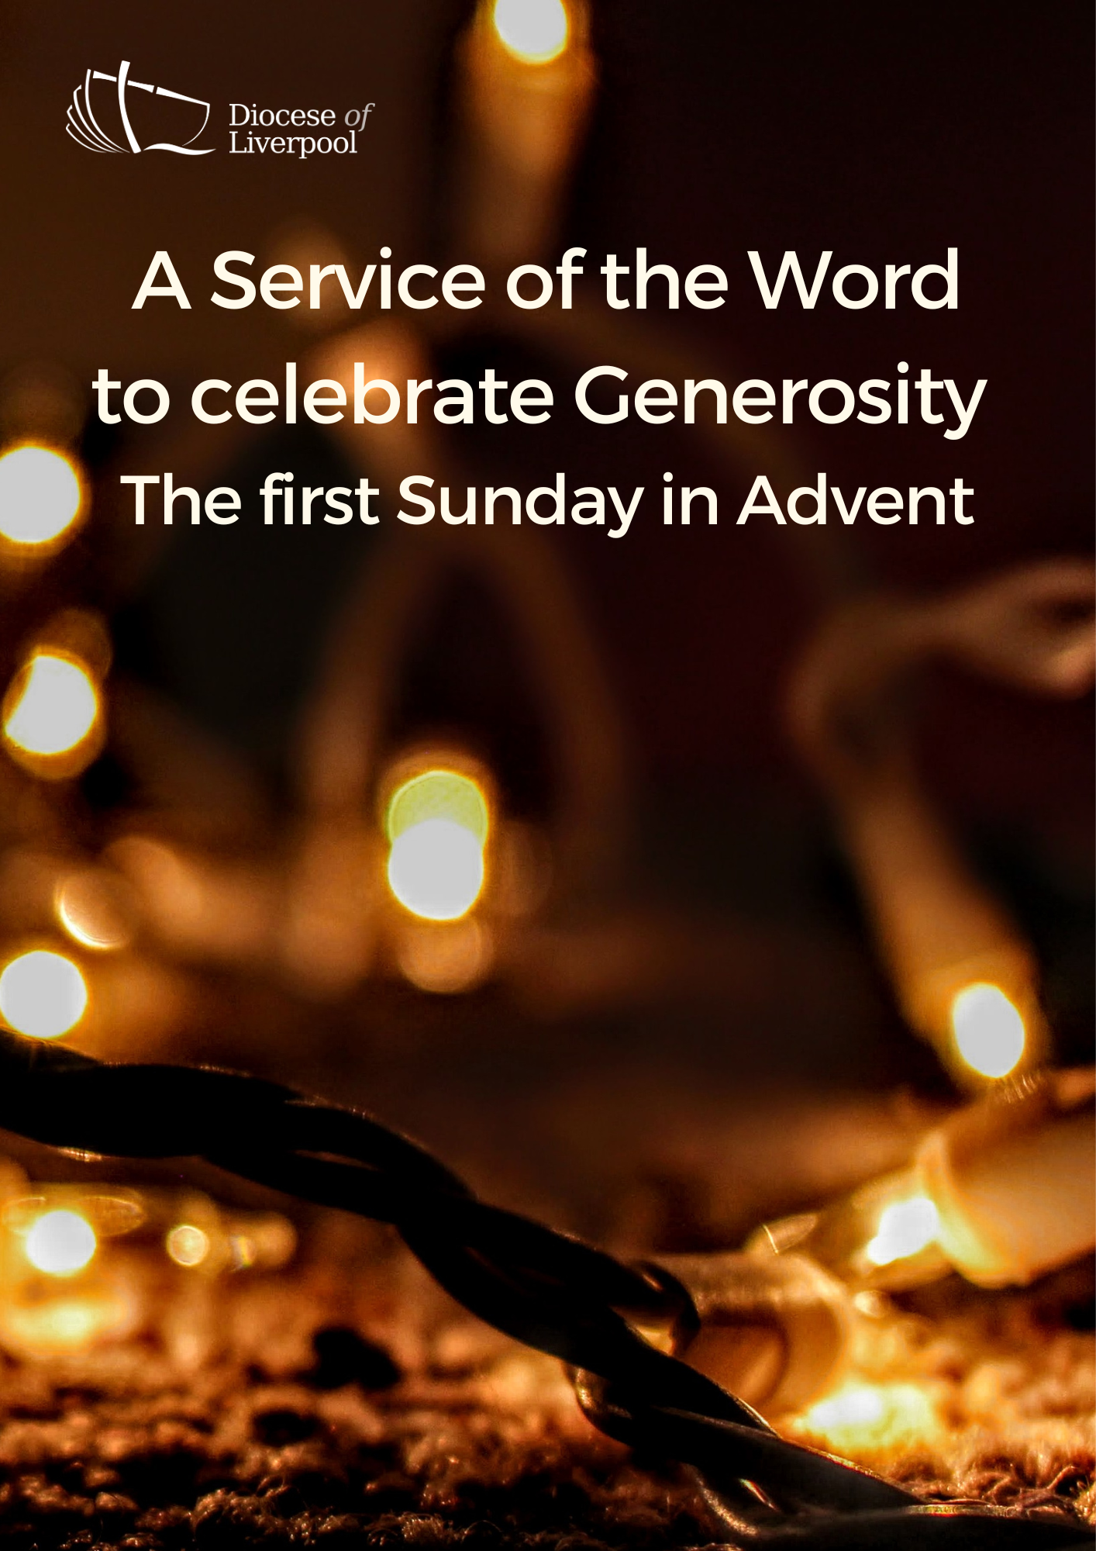

PREPARATION

In preparation for this act of worship, you might wish to pray privately this Ignatian Prayer for Generosity.

Lord, teach me to be generous.
Teach me to serve you as you deserve;
to give and not to count the cost,
to fight and not to heed the wounds,
to toil and not to seek for rest,
to labour and not to ask for reward,
save that of knowing that I do your will.
Amen.

PREPARATION

In the name of the Father,
and of the Son,
and of the Holy Spirit.
Amen.

The Lord is my light and my salvation.
The Lord is my light and my salvation.
With you, O Lord, is the well of life:
In your light shall we see light.
Your word is a lantern to my feet
and a light upon our path.

Blessed are you, Lord our God, King of the universe,
eternal creator of light and darkness.
In this season of Advent,
when the sun's light is swallowed up
by the growing darkness of night,
you renew your promise to reveal among us
the splendour of your glory,
in the gift of Jesus Christ your Son.
Through the prophets
you teach us to hope for his reign of peace.
Through the outpouring of his Spirit,
you open our hearts to live more generously.
Strengthen us as we seek to grow in your likeness,
and free our hearts in gratitude to sing your praise:
for to you all honour and blessing are due,
now and for ever. Amen.

Words of welcome or introduction may be said.

The lighting of the Advent candle may take place here.

Blessed are you, God our Father,
who spoke to your prophets of old
of a Saviour who would bring peace.
Give us thankful hearts as we prepare to celebrate his birth,
that we may share with those around us
the good news of your generous love
shown to us in Jesus,
the light who is coming into the world.
Make us one in the love of Christ
today and for ever. Amen

Prayers of Penitence

As we prepare to receive the gift of the infant Christ,
we remember the times when we have not received graciously,
or lived in the light of our generous God.
Father, you give to us your Son,
yet we receive grudgingly;
Lord, have mercy.
Lord, have mercy.
Jesus, you made yourself poor, that we might become rich,
yet we hoard our possessions and forget to live by your example;
Christ, have mercy.
Christ, have mercy.
Holy Spirit, you bless us with the fruit of generosity,
yet we fail to respond to your call;
Lord, have mercy.
Lord, have mercy.

May the God of all healing and forgiveness
draw us to himself and cleanse us from all our sins,
that we may behold the glory of his Son,
Jesus Christ our Lord. Amen.

Canticle: A Song of David

Splendour and majesty are yours, O God;
you are exalted as head over all.

1 Blessed are you, God of Israel, for ever and ever,
for yours is the greatness, the power,
the glory, the splendour and the majesty.
2 Everything in heaven and on earth is yours;
yours is the kingdom, O Lord,
and you are exalted as head over all.
3 Riches and honour come from you
and you rule over all.
4 In your hand are power and might;
yours it is to give power and strength to all.
5 And now we give you thanks, our God,
and praise your glorious name.
6 For all things come from you,
and of your own have we given you.
1 Chronicles 29.10b-13,14b

Glory to the Father and to the Son
and to the Holy Spirit;
as it was in the beginning is now
and shall be for ever. Amen.

Splendour and majesty are yours, O God;
you are exalted as head over all.

The Collect

Almighty God,
give us grace to cast away the works of darkness
and to put on the armour of light,
now in the time of this mortal life,
in which your Son Jesus Christ came to us in great humility;
that on the last day,
when he shall come again in his glorious majesty
to judge the living and the dead,
we may rise to the life immortal;
through him who is alive and reigns with you,
in the unity of the Holy Spirit,
one God, now and for ever.

God of grace, ever creating and restoring,
you breathe life into all things
and embrace us with an everlasting love;
help us to grow in wonder and awe,
to embody a spirit of gratitude,
and to dream generous dreams;
that, in gathering what we have,
we may graciously offer ourselves
to accomplish what you will,
in Jesus Christ our Lord. Amen.

A children's talk or an all age activity may take place at this point

THE LITURGY OF THE WORD

The First Reading

On the twenty-first day of the seventh month, the word of the Lord came through the prophet Haggai: “Speak to Zerubbabel son of Shealtiel, governor of Judah, to Joshua son of Jozadak, the high priest, and to the remnant of the people. Ask them, ‘Who of you is left who saw this house in its former glory? How does it look to you now? Does it not seem to you like nothing? But now be strong, Zerubbabel,’ declares the Lord. ‘Be strong, Joshua son of Jozadak, the high priest. Be strong, all you people of the land,’ declares the Lord, ‘and work. For I am with you,’ declares the Lord Almighty. ‘This is what I covenanted with you when you came out of Egypt. And my Spirit remains among you. Do not fear.’
“This is what the Lord Almighty says: ‘In a little while I will once more shake the heavens and the earth, the sea and the dry land. I will shake all nations, and what is desired by all nations will come, and I will fill this house with glory,’ says the Lord Almighty. ‘The silver is mine and the gold is mine,’ declares the Lord Almighty. ‘The glory of this present house will be greater than the glory of the former house,’ says the Lord Almighty. ‘And in this place I will grant peace,’ declares the Lord Almighty.”
Now give careful thought to this from this day on – consider how things were before one stone was laid on another in the Lord’s temple. When anyone came to a heap of twenty measures, there were only ten. When anyone went to a wine vat to draw fifty measures, there were only twenty. I struck all the work of your hands with blight, mildew and hail, yet you did not return to me,” declares the Lord. “From this day on, from this twenty-fourth day of the ninth month, give careful thought to the day when the foundation of the Lord’s temple was laid. Give careful thought: is there yet any seed left in the barn? Until now, the vine and the fig-tree, the pomegranate and the olive tree have not borne fruit. ‘“From this day on I will bless you.”’
Haggai 2:1-9; 15-19
This is the Word of the Lord.
Thanks be to God.

Psalmody: Psalm 80

Stir up your mighty strength
and come to our salvation.

1 Hear, O Shepherd of Israel,
you that led Joseph like a flock;
2 Shine forth, you that are enthroned upon the cherubim,
before Ephraim, Benjamin and Manasseh.
3 Stir up your mighty strength
and come to our salvation.
4 Turn us again, O God;
show the light of your countenance, and we shall be saved
5 O Lord God of hosts,
how long will you be angry at your people’s prayer?
6 You feed them with the bread of tears;
you give them abundance of tears to drink.
7 You have made us the derision of our neighbours,
and our enemies laugh us to scorn.
8 Turn us again, O God;
show the light of your countenance, and we shall be saved.

Glory to the Father and to the Son
and to the Holy Spirit;
as it was in the beginning is now
and shall be for ever. Amen.

Stir up your mighty strength
and come to our salvation.

Second Reading

Hear the Gospel of our Lord Jesus Christ, according to Mark.
Glory to you, O Lord.

But in those days, following that distress,
“the sun will be darkened,
and the moon will not give its light;
the stars will fall from the sky,
and the heavenly bodies will be shaken.”
At that time people will see the Son of Man coming in clouds with great power and glory. And he will send his angels and gather his elect from the four winds, from the ends of the earth to the ends of the heavens.
Now learn this lesson from the fig-tree: as soon as its twigs get tender and its leaves come out, you know that summer is near. Even so, when you see these things happening, you know that it is near, right at the door. Truly I tell you, this generation will certainly not pass away until all these things have happened. Heaven and earth will pass away, but my words will never pass away.
But about that day or hour no one knows, not even the angels in heaven, nor the Son, but only the Father. Be on guard! Be alert! You do not know when that time will come. It’s like a man going away: he leaves his house and puts his servants in charge, each with their assigned task, and tells the one at the door to keep watch. Therefore keep watch because you do not know when the owner of the house will come back – whether in the evening, or at midnight, or when the cock crows, or at dawn. If he comes suddenly, do not let him find you sleeping. What I say to you, I say to everyone: “Watch!”’
Mark 13:24-37
This is the Gospel of the Lord.
Praise to you, O Christ.

The Sermon

Affirmation of Faith

Let us affirm our faith in God.

We believe in God the Father,
from whom every family
in heaven and on earth is named.
We believe in God the Son,
who lives in our hearts through faith,
and fills us with his love.
We believe in God the Holy Spirit,
who strengthens us
with power from on high.
We believe in one God;
Father, Son and Holy Spirit.
Amen.
cf Ephesians 3

PRAYERS
A Litany of Thanksgiving

Let us give thanks to God
for his gifts so generously given to us,
and for the blessings we each abundantly receive.

For the beauty of creation,
for the wonder of new life,
for all things seen and unseen.
We give you thanks, O God. Psalm 75.1

For the gift of life that you breathe into us,
for minds to think, hearts to love, and hands to serve.
We give you thanks, O God.

For our families and friends,
for all who we love and who love us,
for your image revealed through those around us.
We give you thanks, O God.

For life of your church,
its vibrancy and diversity,
for the mission in which we all share.
We give you thanks, O God.

For the vocations in which you call us,
for the skills which are nurtured and grow,
for our ministries in all walks of life.
We give you thanks, O God.

For your creativity planted in each person,
for voices to sing our praises to you,
for our capacity to create.
We give you thanks, O God.

For your love which brings us peace even in the darkest of times,
for your strength when we feel weak and vulnerable,
for your hope when all seems lost.
We give you thanks, O God.

For all financial gifts offered to our church,
for blessings offered to be a blessing to others,
for sacrifices made to further mission and enable us to be Christ in the world.
We give you thanks, O God.

For the generosity of this community,
for all who give their time and skills,
for the gifts which are built up and encouraged,
for acts which point beyond themselves and reveal your glory.
We give you thanks, O God.

For you, O God,
for your beauty revealed in all things around us,
for love and life everlasting.
We give you thanks, O God.

For the wisdom of your Spirit,
for gifts given and nurtured,
for sustaining us in prayer.
We give you thanks, O God.

For your Son, Jesus Christ,
for the gift of his perfect sacrifice,
for our hope in him, and the joy of serving his Church.
We give thanks to you, O God.

Intercessions

In joyful expectation of the gift of the Infant Christ,
we pray to Jesus saying;
Maranatha.
Come, Lord Jesus.

Come to your Church as Lord and judge.
We pray for our local community In this parish,
that we might bless those around us this Advent with joy and grace.
Help us to live In the light of your coming
and giving us a longing for your kingdom.
Maranatha.
Come, Lord Jesus.

Come to your world as King of the nations.
We pray for those who lead and govern this country,
that they might take courage from generosity In their relationships,
and lead with humility.
Before you rulers will stand in silence.
Maranatha.
Come, Lord Jesus.

Come to the suffering as Saviour and comforter.
We pray for your gift of peace,
and for the spirit of receiving graciously when we are In need.
Break into those areas of our lives
where we struggle with sickness and distress,
and set us free to serve you for ever.
Maranatha.
Come, Lord Jesus.

Come to us from heaven with power and great glory.
Lift us up to meet you,
that with all your saints and angels
we may live and reign with you In your new creation.
Maranatha.
Come, Lord Jesus.

Silence is kept.

Source of all life and giver of all that is good,
give to your people who trust in your love
a spirit of joy in generosity.
By your coming, raise us to share in the joy of your kingdom
on earth as in heaven,
and make us one in heart and mind
to serve you with joy forever.
Amen.

The Offering

An offering is taken, which may be virtual, giving time
for people to reflect on gifts given electronically.

God of all creation,
the source of life and giver of all good things;
through your goodness you have blessed us with all we have.
We bring before you these gifts of gratitude, given in many ways.
With them we offer our lives;
that we may be used to serve others,
and give you glory.
We make our prayer
in the name of Jesus Christ,
who is the perfect gift incarnate.
Amen.

THE DISMISSAL

May Christ, who for our sake became poor
make you rich in everything -
in faith, generosity, grace and love;
and the blessing of God almighty,
the Father, the Son, and the Holy Spirit,
be among you and remain with you always.
Amen.

Material in this order of service is taken from Common Worship, copyright © The Archbishops’ Council 2000-2006 and is used here with permission. www.commonworship.com. This order has been compiled by Sammi Tooze.

