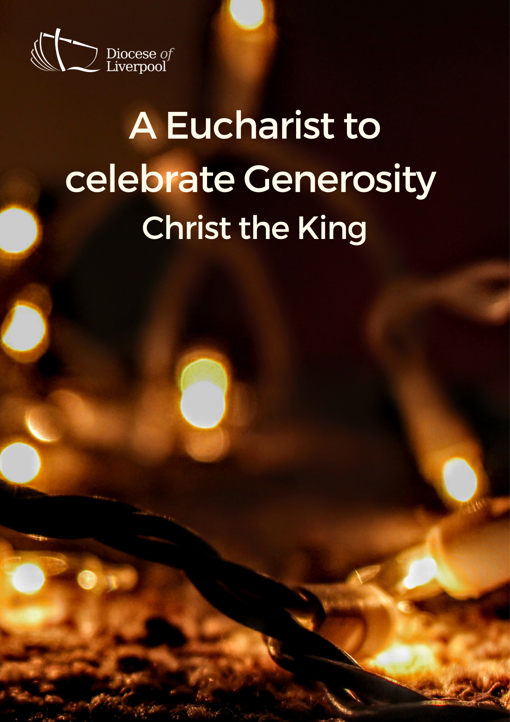

PREPARATION

In preparation for this act of worship, you might wish to pray privately this Prayer of General Thanksgiving.

Accept, O Lord, our thanks and praise for all that you have done for us.

We thank you for the splendour of the whole creation,
for the beauty of this world, for the wonder of life,
and for the mystery of love.

We thank you for the blessing of family and friends,
and for the loving care which surrounds us on every side.

We thank you for setting us at tasks which demand our best efforts,
and for leading us to accomplishments which satisfy and delight us.

We thank you also for those disappointments and failures
that lead us to acknowledge our dependence on you alone.

Above all, we thank you for your Son Jesus Christ;
for the truth of his Word and the example of his life;
for his steadfast obedience, by which he overcame temptation;
for his dying, through which he overcame death;
and for his rising to life again,
in which we are raised to the life of your kingdom.

Grant us the gift of your Spirit,
that we may know him and make him known;
and through him, at all times and in all places,
may give thanks to you in all things. Amen.
Prayer of General Thanksgiving, BCP New York 1979
THE GATHERING

In the name of the Father,
and of the Son,
and of the Holy Spirit. Amen.

Enter the gates of the Lord with thanksgiving,
and enter his courts with praise.
Give thanks to the Lord
and bless his name.
For the Lord is good;
his steadfast love endures forever. cf. Psalm 100.4-5

For the gift of his Spirit: blessed be Christ.
For the catholic Church: blessed be Christ.
For the means of grace: blessed be Christ.
For the hope of glory: blessed be Christ.
For the triumphs of his gospel: blessed be Christ.
For the lives of his saints: blessed be Christ.
In joy and In sorrow: blessed be Christ.
In life and in death: blessed be Christ.
Now and to the end of the ages: blessed be Christ.
(Church in Wales, Daily Prayer)

Prayers of Penitence

When our natural fears and anxieties push you
to the margins of our lives,
Lord, have mercy.
Lord, have mercy.

When we are so preoccupied with our concerns
that we cannot seek first your kingdom or put our trust in you,
Christ, have mercy.
Christ, have mercy.

When disappointment leads to doubt,
when fear hinders faith and we cannot see the glory which will be,
Lord, have mercy.
Lord, have mercy.

Almighty God,
who in Jesus Christ has given us
a kingdom that cannot be destroyed,
forgive us our sins,
open our eyes to God’s truth,
strengthen us to do God’s will
and give us the joy of his kingdom,
through Jesus Christ our Lord.
Amen.

Gloria in Excelsis

Glory to God in the highest,
and peace to his people on earth.
Lord God, heavenly King,
almighty God and Father,
we worship you, we give you thanks,
we praise you for your glory.
Lord Jesus Christ, only Son of the Father,
Lord God, Lamb of God,
you take away the sin of the world:
have mercy on us;

you are seated at the right hand of the Father:
receive our prayer.
For you alone are the Holy One,
you alone are the Lord,
you alone are the Most High, Jesus Christ,
with the Holy Spirit,
in the glory of God the Father.
Amen.

The Collect
God the Father,
help us to hear the call of Christ the King
and to follow in his service,
whose kingdom has no end;
for he reigns with you and the Holy Spirit,
one God, one glory. Amen.

A children's talk or an all age activity may take place at this point
THE LITURGY OF THE WORD
The First Reading
In the second year of King Darius, on the first day of the sixth month, the word of the Lord came through the prophet Haggai to Zerubbabel son of Shealtiel, governor of Judah, and to Joshua son of Jozadak, the high priest: This is what the Lord Almighty says: ‘These people say, “The time has not yet come to rebuild the Lord’s house.”’
Then the word of the Lord came through the prophet Haggai: ‘Is it a time for you yourselves to be living in your panelled houses, while this house remains a ruin?’ Now this is what the Lord Almighty says: ‘Give careful thought to your ways. You have planted much, but harvested little. You eat, but never have enough. You drink, but never have your fill. You put on clothes, but are not warm. You earn wages, only to put them in a purse with holes in it.’
This is what the Lord Almighty says: ‘Give careful thought to your ways. Go up into the mountains and bring down timber and build my house, so that I may take pleasure in it and be honoured,’ says the Lord. ‘You expected much, but see, it turned out to be little. What you brought home, I blew away. Why?’ declares the Lord Almighty. ‘Because of my house, which remains a ruin, while each of you is busy with your own house. Therefore, because of you the heavens have withheld their dew and the earth its crops. I called for a drought on the fields and the mountains, on the grain, the new wine, the olive oil and everything else the ground produces, on people and livestock, and on all the labour of your hands.’
Then Zerubbabel son of Shealtiel, Joshua son of Jozadak, the high priest, and the whole remnant of the people obeyed the voice of the Lord their God and the message of the prophet Haggai, because the Lord their God had sent him. And the people feared the Lord.
Then Haggai, the Lord’s messenger, gave this message of the Lord to the people: ‘I am with you,’ declares the Lord. So the Lord stirred up the spirit of Zerubbabel son of Shealtiel, governor of Judah, and the spirit of Joshua son of Jozadak, the high priest, and the spirit of the whole remnant of the people. They came and began to work on the house of the Lord Almighty, their God, on the twenty-fourth day of the sixth month. Haggai 1:1-15

This is the Word of the Lord.
Thanks be to God.

Gospel Reading
Hear the Gospel of our Lord Jesus Christ, according to John.
Glory to you, O Lord.

Pilate then went back inside the palace, summoned Jesus and asked him, ‘Are you the king of the Jews?’ ‘Is that your own idea,’ Jesus asked, ‘or did others talk to you about me?’

‘Am I a Jew?’ Pilate replied. ‘Your own people and chief priests handed you over to me. What is it you have done?’ Jesus said, ‘My kingdom is not of this world. If it were, my servants would fight to prevent my arrest by the Jewish leaders. But now my kingdom is from another place.’

‘You are a king, then!’ said Pilate. Jesus answered, ‘You say that I am a king. In fact, the reason I was born and came into the world is to testify to the truth. Everyone on the side of truth listens to me.’
John 18:33-37
This is the Gospel of the Lord.
Praise to you, O Christ.

The sermon

The Creed
We believe in one God, the Father, the Almighty,
maker of heaven and earth, of all that is, seen and unseen.

We believe in one Lord, Jesus Christ,
the only Son of God,
eternally begotten of the Father,
God from God, Light from Light,
true God from true God,
begotten, not made,
of one Being with the Father;
through him all things were made.
For us and for our salvation he came down from heaven,
was incarnate from the Holy Spirit and the Virgin Mary
and was made man.
For our sake he was crucified under Pontius Pilate;
he suffered death and was buried.
On the third day he rose again
in accordance with the Scriptures;
he ascended into heaven
and is seated at the right hand of the Father.
He will come again in glory to judge the living and the dead,
and his kingdom will have no end.

We believe in the Holy Spirit,
the Lord, the giver of life,
who proceeds from the Father and the Son,
who with the Father and the Son is worshipped and glorified,
who has spoken through the prophets.
We believe in one holy catholic and apostolic Church.
We acknowledge one baptism for the forgiveness of sins.
We look for the resurrection of the dead,
and the life of the world to come. Amen.
PRAYERS

The Lord says, ‘My house remains a ruin, while each of you is busy with their own house.’
Lord, we pray for the ministry and mission of this church. Set us free from the fearfulness that turns us inward. Grant a renewed vision of what it is for us to be your church, in this place, at this time. [Especially we pray for … ]
Stir up our spirits Lord,
that we might see your glory in our midst.
The Lord says, ‘Give careful thought to your ways.
Lord, help us to know that you are the owner and giver of all we have. Grant us grace to consider our lifestyles, our money choices and our financial goals so that you may be Lord of all. [Especially we pray for …]
Stir up our spirits Lord,
that we might see your glory in our midst.
The Lord says, 'I am with you.'
Lord, you have promised to provide all we need. But our hearts are anxious, for ourselves, our loved ones, our community, our nation. We pray for all those who struggle. [Especially we pray for …]
Stir up our spirits Lord,
that we might see your glory in our midst.
The Lord says, ‘Be strong, for I am with you. My Spirit remains among you. Do not fear.'
Lord we remember before you those who struggle in mind, body or spirit [remembering especially …] We remember also those who have died and those who live now with the pain of bereavement, [remembering especially …] Grant, to each Lord, your promise that,’ In this place I will grant peace.’
Stir up our spirits Lord,
that we might see your glory in our midst.
The Lord says, ‘This people say, the time has not yet come to rebuild the Lord's house
Lord, give us grace to stay faithful and centred on you. Keep us from holding you at the margins of our lives. Instead, let our lives declare the glory of your presence, in our hearts and homes, in our church and in our nation.
Grant us the right attitude towards our possessions
and a generous heart in the use of the gifts that you give to us;
that by our actions we may glorify you,
with the Father and the Holy Spirit, one God, now and for ever. Amen.
Merciful Father
accept these prayers for the sake of your Son,
our Saviour Jesus Christ. Amen.

THE LITURGY OF THE SACRAMENT

The Peace
May God stir up in us and in the world
the gift of peace and peacefulness towards all.

The peace of the Lord be always with you
and also with you.

All are invited to exchange a sign of peace.

An offering is received, giving time for people to reflect on gifts given electronically. The table is prepared and bread and wine are placed upon it.

Prayer over the Offering
God of all creation,
you have blessed us with many gifts
and stir up within us generous hearts.
We give you thanks
for all that has been offered back to you,
gifts of gratitude, given in many ways;
in the name of Jesus Christ. Amen

Taking of the Bread and Wine

Blessed are you, Lord God of abundance:
through your goodness we have this bread to set before you,
which earth has given and human hands have made.
It will become for us the bread of life.
Blessed be God for ever.

Blessed are you, Lord God of abundance:
through your goodness we have this wine to set before you,
fruit of the wine and work of human hands.
It will become for us the cup of salvation.
Blessed be God for ever.

The Eucharistic Prayer

The Lord be with you (or) The Lord is here.
and also with you. His Spirit is with us.
Lift up your hearts.
We lift them to the Lord.
Let us give thanks to the Lord our God.
It is right to give thanks and praise.

It is indeed right and good to give you thanks and praise,
almighty God and everlasting Father,
through Jesus Christ your Son.
For when he humbled himself to come among us in human flesh,
he modelled the true spirit of generosity and self-giving love.

And now we give you thanks
that he is the King of glory,
who overcomes the sting of death
and opens the kingdom of heaven to all believers.
He is seated at your right hand in glory
and we believe that he will come to be our judge.

And so we join our voices with angels and archangels
and with the whole company of heaven
to proclaim your glory,
for ever praising you and saying:

Holy, holy, holy Lord,
God of power and might,
heaven and earth are full of your glory.
Hosanna in the highest.
Blessed is he who comes in the name of the Lord.
Hosanna in the highest.

We praise and bless you, loving Father,
through Jesus Christ, our Lord;
and as we obey his command,
send your Holy Spirit,
that broken bread and wine outpoured
may be for us the body and blood of your dear Son.

On the night before he died he had supper with his friends
and, taking bread, he praised you.

He broke the bread, gave it to them and said:
Take, eat; this is my body which is given for you;
do this in remembrance of me.

When supper was ended he took the cup of wine.
Again he praised you, gave it to them and said:
Drink this, all of you;
this is my blood of the new covenant,
which is shed for you and for many for the forgiveness of sins.
Do this, as often as you drink it, in remembrance of me.

So, Father, we remember all that Jesus did,
in him we plead with confidence his sacrifice
made once for all upon the cross.
Bringing before you the bread of life and cup of salvation,
we proclaim his death and resurrection
until he comes in glory.

Praise to you, Lord Jesus:
Dying you destroyed our death,
rising you restored our life:
Lord Jesus, come in glory.

Lord of all life,
help us to work together for that day
when your kingdom comes
and justice and mercy will be seen in all the earth.

Look with favour on your people,
gather us in your loving arms
and bring us with [N and] all the saints
to feast at your table in heaven.
Through Christ, and with Christ, and in Christ,
in the unity of the Holy Spirit,
all honour and glory are yours, O loving Father,
for ever and ever. Amen.
Rejoicing in the gift of his presence among us,
as our Saviour taught us, so we pray
Our Father in heaven,
hallowed be your name,
your kingdom come,
your will be done,
on earth as in heaven.
Give us today our daily bread.
Forgive us our sins
as we forgive those who sin against us.
Lead us not into temptation
but deliver us from evil.
For the kingdom, the power,
and the glory are yours
now and for ever. Amen.

We break this bread to share in the body of Christ.
Though we are many, we are one body,
because we all share in one bread.

(or)

O taste and see that the Lord is gracious;
blessed is the one who trusts in him.

God’s holy gifts
for God’s holy people.
Jesus Christ is holy,
Jesus Christ is Lord,
to the glory of God the Father.

Communion is administered.

Prayer after Communion

Loving and righteous God,
here at your table we have tasted your goodness and generosity
which exceeds all that we can desire or deserve;
liberate us from all jealousy and greed,
that we may respond cheerfully by offering ourselves,
and love and serve others to witness to your coming glory;
in the name of Jesus Christ our Lord. Amen.

Stir up, O Lord,
the wills of your faithful people;
that they, plenteously bringing forth the fruit of good works,
may by you be plenteously rewarded;
through Jesus Christ our Lord. Amen

THE DISMISSAL

The God of grace enrich us in every way,
with hearts overflowing with thanksgiving to God;
and the blessing of God almighty,
the Father, the Son, and the Holy Spirit,
be among you and remain with you always. Amen.

Go in peace to love and serve the Lord.
In the name of Christ. Amen.

Material in this order of service is taken from Common Worship, copyright © The Archbishops’ Council 2000-2006 and is used here with permission. www.commonworship.com. This order has been compiled by Sammi Tooze.

