Permission to Officiate (PtO) Pathway

Participant Workbook

  - Name:
  - Role:
  - Deanery/Church/Cathedral Name:

  - April 2024
  - 1. Introduction
- The national safeguarding learning and development practice guidance sets out the framework for safeguarding learning to ensure that all Church officers develop skills and knowledge in safeguarding to an appropriate level.
- This Learning Pathway builds on the Basic Awareness and Foundation modules, available online at the Church of England’s learning portal.
- This pathway provides a chance to reflect on safeguarding in a church setting. Rather than focusing on simply providing information or ‘step-by-step’ guides, this pathway encourages reflection on the foundations and priorities of good safeguarding and how to contribute to its development.

This learning pathway has been built around these National Safeguarding Standards:

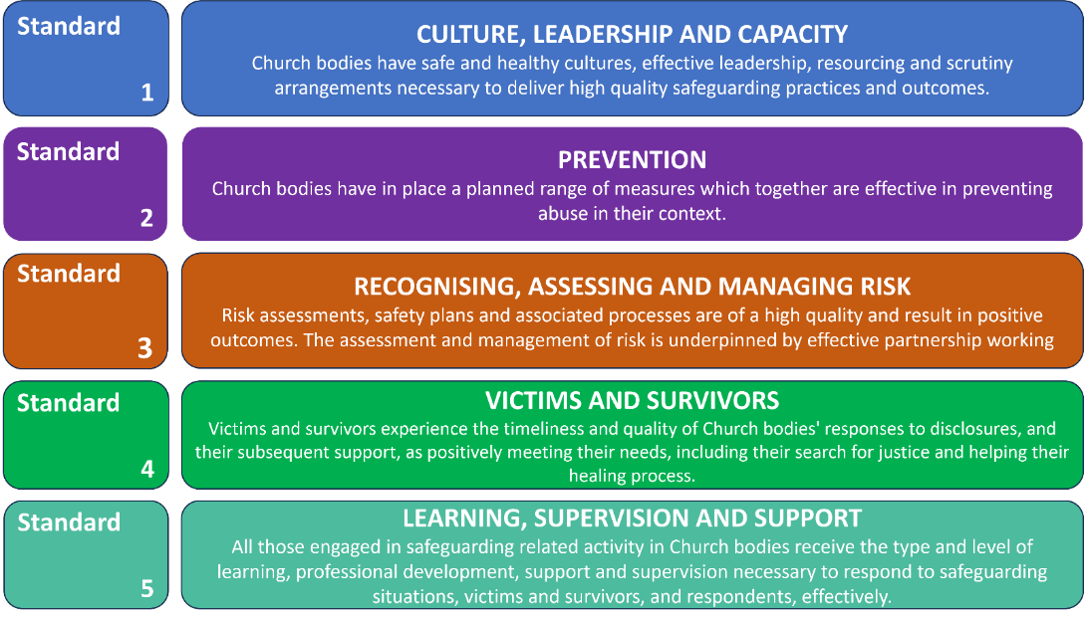

2. Learning Outcomes of this pathway
This pathway is intended to be transformational. Once people have completed it, the aim is that they are in some way different from the people they were before it. The aim is that participants reflect on their own values and beliefs and integrate these with the values and beliefs underpinning good safeguarding behaviour. The idea is that good safeguarding behaviour can then flow from an inner motivation, rather than be experienced as an external process to be followed under duress.
By the end of this pathway participants will:
- Connect the Church’s mission and theological foundations with what good leadership behaviour looks like in a safeguarding context.
- Evaluate aspects of their own practice and identify changes required which they then take forward with confidence.
- Analyse what healthy Christian communities look like, how healthy communities keep people safe, and their role as leaders in shaping Christian communities that are healthy and safe.
- Integrate their own faith, beliefs, and values with those underpinning good safeguarding behaviours.

3. Structure of this pathway
- There are several components to this pathway; you are on a learning journey in respect of safeguarding which we would want you to continue after your involvement in this specific pathway.

- The focus of the session is on the exploration of what effective behaviour looks like in respect of safeguarding and connecting this to an understanding of how the culture of a Christian community protects people.

Preparation for the session

You are asked to complete three tasks before the session:

Reflect on three questions (detailed below) and answer them as carefully and honestly as possible.

In order to get the most from this pathway, it is important that you engage in some personal reflection in advance. The purpose of these questions is not for you to produce the ‘right’ answer, but to reflect on your own views, experiences, and values so that you come to the session prepared to engage in the discussions.

Please write your answers in a way that most helps you to learn; your notes are your own to assist you in the conversations during the session.

Your personal reflections could also be informed by some reading of the recommended key texts listed on pages 16-17. But please note that this is not a requirement as we are aware that not everyone will have the time to do this reading – but some will.
- Identify what has influenced your values and beliefs regarding safeguarding.
Please identify one thing that reflects what has influenced your individual connection with safeguarding and underpins your values and beliefs regarding safeguarding. This might be an abstract conceptualisation linked to song lyrics, nature, or literature, or may be informed by your own theology, religious scripture, or teachings.
We ask that you come prepared to this session being able to share what is influenced you and explore how this has informed your responses, values, and beliefs regarding safeguarding.
Examples:
Thomas Jefferson / Mahatma Gandhi “The true measure of any society can be found in how it treats its most vulnerable members.”
“Speak up for those who cannot speak for themselves, for the rights of all who are destitute. Speak up and judge fairly; defend the rights of the poor and needy’ (Proverbs 31:8).
Proverb- “It takes a village to raise a child”
Mark 12:30-31 (ESV) And you shall love the Lord your God with all your heart and with all your soul and with all your mind and with all your strength.’ The second is this: ‘You shall love your neighbour as yourself.’ There is no other commandment greater than these.”

Read the Parish Safeguarding Handbook.

Question 1

If a faith culture is safe and healthy what would you expect to see, hear, feel and experience as a member?

When reflecting on this question you may like to think about how a faith community might:

listen to a wide range of voices

communicate clearly and consistently its safeguarding values and beliefs

manage power

respond to vulnerability

empower everyone, especially those more vulnerable

ensure freedom of choice

signal acceptable behaviour / practices

challenge unacceptable behaviour / practices

embrace diversity

review to learn and improve

Please write your answer below

Question 2

How do you see your role and responsibilities in relation to safeguarding and creating a healthy culture?

Please write your answer below

Question 3

What is your understanding of how a healthy culture can help to reduce risk of harm and prevent safeguarding incidents?

Please write your answer below

Break
Part 2 – Safeguarding Reflection and Issue based discussion.
Safeguarding is at the centre of our faith, in our practice, in our worship, in our praying, and in our believing. This means that, if safeguarding is going to become part of our core DNA, we need to see it theologically as well as morally and practically. Theology, by which we simply mean clear thinking about God and the faith we share, needs to be interwoven into all our learning and the development pathways.
The point is simply that good theology is a vital part of good safeguarding. If our theology is connected to our safeguarding practice, then there is less chance of theology being misused and therefore contributing to the abuse of victims and survivors. Moreover, once the links are pointed out, ministers start to weave safeguarding into all that they do.
The first part of this section is the safeguarding reflection. In preparation you were asked to identify what has influenced your values and beliefs regarding safeguarding, this exercise allows space for participants to share what has influenced them and explore how this has informed their responses, values, and beliefs regarding safeguarding.

There will follow a discussion of key safeguarding related issues.

Break

Part 3 – Safeguarding Case Study.

The rest of the session focuses on the case study which will be presented by the facilitators for group discussion.

As a final exercise at the end of the session, please note :

- three things you will take away from today.
- any ways in which the pathway has enriched your theological awareness of God, the world, and church
- any difference this learning experience will make in your role in public ministry.

Consolidation and Evaluation

The history and experience of evaluation in “safeguarding training” – across all sectors, not just the Church - is that it tends to focus on the immediate self-reported capturing of people’s experience of the session itself. The limitation of this is that we just do not know if such training is having any impact – do people just “attend” the training event, tick that box, and carry on as before?

The evaluation that really matters is whether the “learning experience” has affected someone’s beliefs, values and understanding at a deep level so that there is a change in the person’s behaviours. They now do things not because they must do something, but because they really want to exhibit those behaviours. This is called “second order” change – when people do things because there is an inner motivation.

So, if this “learning experience” has been effective, a participant will, in some respects, be a different person from the one that started the experience.

The purpose of evaluation, then, is to try to find out if any difference has indeed been achieved.
At the beginning of the workbook, we set out the learning outcomes the programme is designed to deliver, and they are repeated here.
By the end of this pathway participants will:
- Connect the Church’s mission and theological foundations with what good leadership behaviour looks like in a safeguarding context.
- Evaluate aspects of their own practice and identify changes required which they then take forward with confidence.
- Analyse what healthy Christian communities look like, how healthy communities keep people safe, and their role as leaders in shaping Christian communities that are healthy and safe.
- Integrate their own faith, beliefs, and values with those underpinning good safeguarding behaviours.

The evaluation task.

If this learning programme has been successful, there will be evidence of the above behaviours which others will be able to see. The evaluation task, therefore, is:

- Four to six weeks after the session, write a short reflection on your learning from this pathway.

Your reflection should be submitted to the safeguarding team at : safeguarding.team@liverpool.anglican.org who will review it. It is only after facilitators have received the completed reflection that the certificate of completion for this pathway will be issued.

PtO Safeguarding Pathway - Self-reflection
Your name: Location:
Role: Date:

As a Church, we consider it important that our leaders maintain the necessary knowledge, attitudes, and skills to safeguard and protect children, young people, and vulnerable adults. Also, to understand safeguarding as a theological imperative, rooted in the nature and love of God and demonstrated in behaviours, attitudes and language that give equal value to all.
The overall aim is for the Church to bring about a shift in our relationship with safeguarding, whereby guarding the safety of others flows from the very core of all our behaviours - where safeguarding is more than about ticking a box and is integral to all that we do.

Self-Reflection
Having now completed the PtO Safeguarding Pathway please reflect on your learning from the sessions and its integration in your practice.

- What difference have I noticed in myself in my approach to safeguarding? (e.g., knowledge, attitude, language, importance/integration within my work)

- What opportunity do I have, or could use, to create a healthy church community?

- What would it look like for me to demonstrate behaviours that give equal value to all?

Safeguarding Team Contact Details
Andy Holmes, Diocesan Safeguarding Adviser
07940 378139 andrew.holmes@liverpool.anglican.org
Mick Murphy, Deputy Diocesan Safeguarding Adviser
07376431466 michael.murphy@liverpool.anglican.org
Karen Williams, Assistant Diocesan Safeguarding
07946 189061 karen.williams@liverpool.anglican.org
Deborah Doran, Safeguarding Support - contact for issues relating to Safer Recruiter, DBS, Parish Safeguarding Officer Support and Lead and Additional Recruiter information. Hours of work, Tuesday and Wednesday 8:30 - 5:30 pm. Tel 0151 705 2124, email: deborah.doran@liverpool.anglican.org
Further information/resources and websites.
Key relevant texts

Oakley & Humphries (2019) Escaping the Maze of Spiritual Abuse. Creating Healthy Christian Cultures. SPCK Publishing. https://spckpublishing.co.uk/escaping-the-maze-of-spiritual-abuse
Fife, Janet and Gilo (2019), Letters to a Broken Church. Ekklesia.
Harper and Wilson (2019) To Heal and Not to Hurt: A fresh approach to safeguarding in Church, Darton, Longman and Todd
Merchant (2020), Broken by Fear, Anchored in Hope: Faithfulness in an age of anxiety. SPCK Publishing. https://spckpublishing.co.uk/broken-by-fear-anchored-in-hope
Chevous, Jane (2004) From Silence to Sanctuary: A guide to understanding, preventing, and responding to abuse, SPCK Publishing. https://spckpublishing.co.uk/from-silence-to-sanctuary-pb
Southgate et al (2020) Tragedies and Christian Congregations: The Practical Theology of Trauma, Routledge. Tragedies and Christian Congregations: The Practical Theology of Trauma (routledge.com)

The Independent Inquiry into Child Sexual Abuse, Report on The Anglican Church
The Anglican Church: Safeguarding in the Church of England and the Church in Wales (iicsa.org.uk)
The SCIE overview report
SCIE Final overview report of the independent diocesan safeguarding audits and additional work on improving responses to survivors of abuse.pdf (churchofengland.org)
The Church of England’s safeguarding policies and where to find them.
https://www.churchofengland.org/safeguarding/promoting-safer-church/policy-practice-guidance
Code of Safer Working Practice 02.07.2021.pdf (churchofengland.org)

Guidelines for the Professional Conduct of Clergy - The Guidelines | The Church of England

Websites
www.nspcc.org.uk (national Society for the prevention of cruelty to children)
www.womensaid.org.uk (Female domestic abuse charity)
www.restoredrelationships.org (Christian domestic abuse charity)
www.mankind.org.uk (Male domestic abuse charity)
www.stopitnow.org.uk (child safeguarding organization)
www.scie.org.uk (Social Care Institute for Excellence)
www.ceop.police.uk (child exploitation and online protection command)
www.elderabuse.org.uk (adult safeguarding charity)
www.ageuk.org.uk (adult safeguarding charity)
www.barnardos.org.uk (child protection charity)
www.theclewerinitiative.org (modern slavery charity)
www.modernslavery.co.uk (modern slavery charity)
www.macsas.org.uk (survivor advocacy charity)

Helplines for further support
- Safe Spaces –
Safe Spaces is for anyone who feels they have experienced church-related abuse of any form in England or Wales. Safe Spaces comprises a team of trained support advocates who have undergone specialist training in supporting survivors of sexual violence and who have received additional specific training in how the churches respond to abuse cases, the way in which faith and church-related settings have been used to carry out abuse, and the issues affecting people who have had or still have, a relationship with the church. You can contact the Safe Spaces team by: -
Tel: 0300 303 1056
(Answerphone available outside of opening times)
- Email: safespaces@firstlight.org.uk
- A live chat service is also available through the Safe Spaces website - Safe Spaces England and Wales – Safe Spaces England and Wales
- The Safe Spaces team are available through their helpline and live chat service on:
- Opening Times: Monday - Friday: 9am-9pm Saturday: 9am-1pm Sunday: 1pm-5pm

- NSPCC - For adults concerned about a child 0808 800 5000
- ChildLine - For children and young people on 0800 1111
- Action on Elder Abuse helpline 0808 808 8141
- 24-hour National Domestic Violence Helpline 0808 2000 247
- NAPAC – Offer support and advice to adult survivors of childhood abuse 0808 801 0331
- Stop It Now – preventing child sexual abuse 0808 1000 900
- Cruse – bereavement helpline 0808 808 1677

A ‘Church officer’ is anyone appointed/elected by or on behalf of the Church to a post or role, whether they are ordained or lay, paid or unpaid.
National Safeguarding Standards | The Church of England

