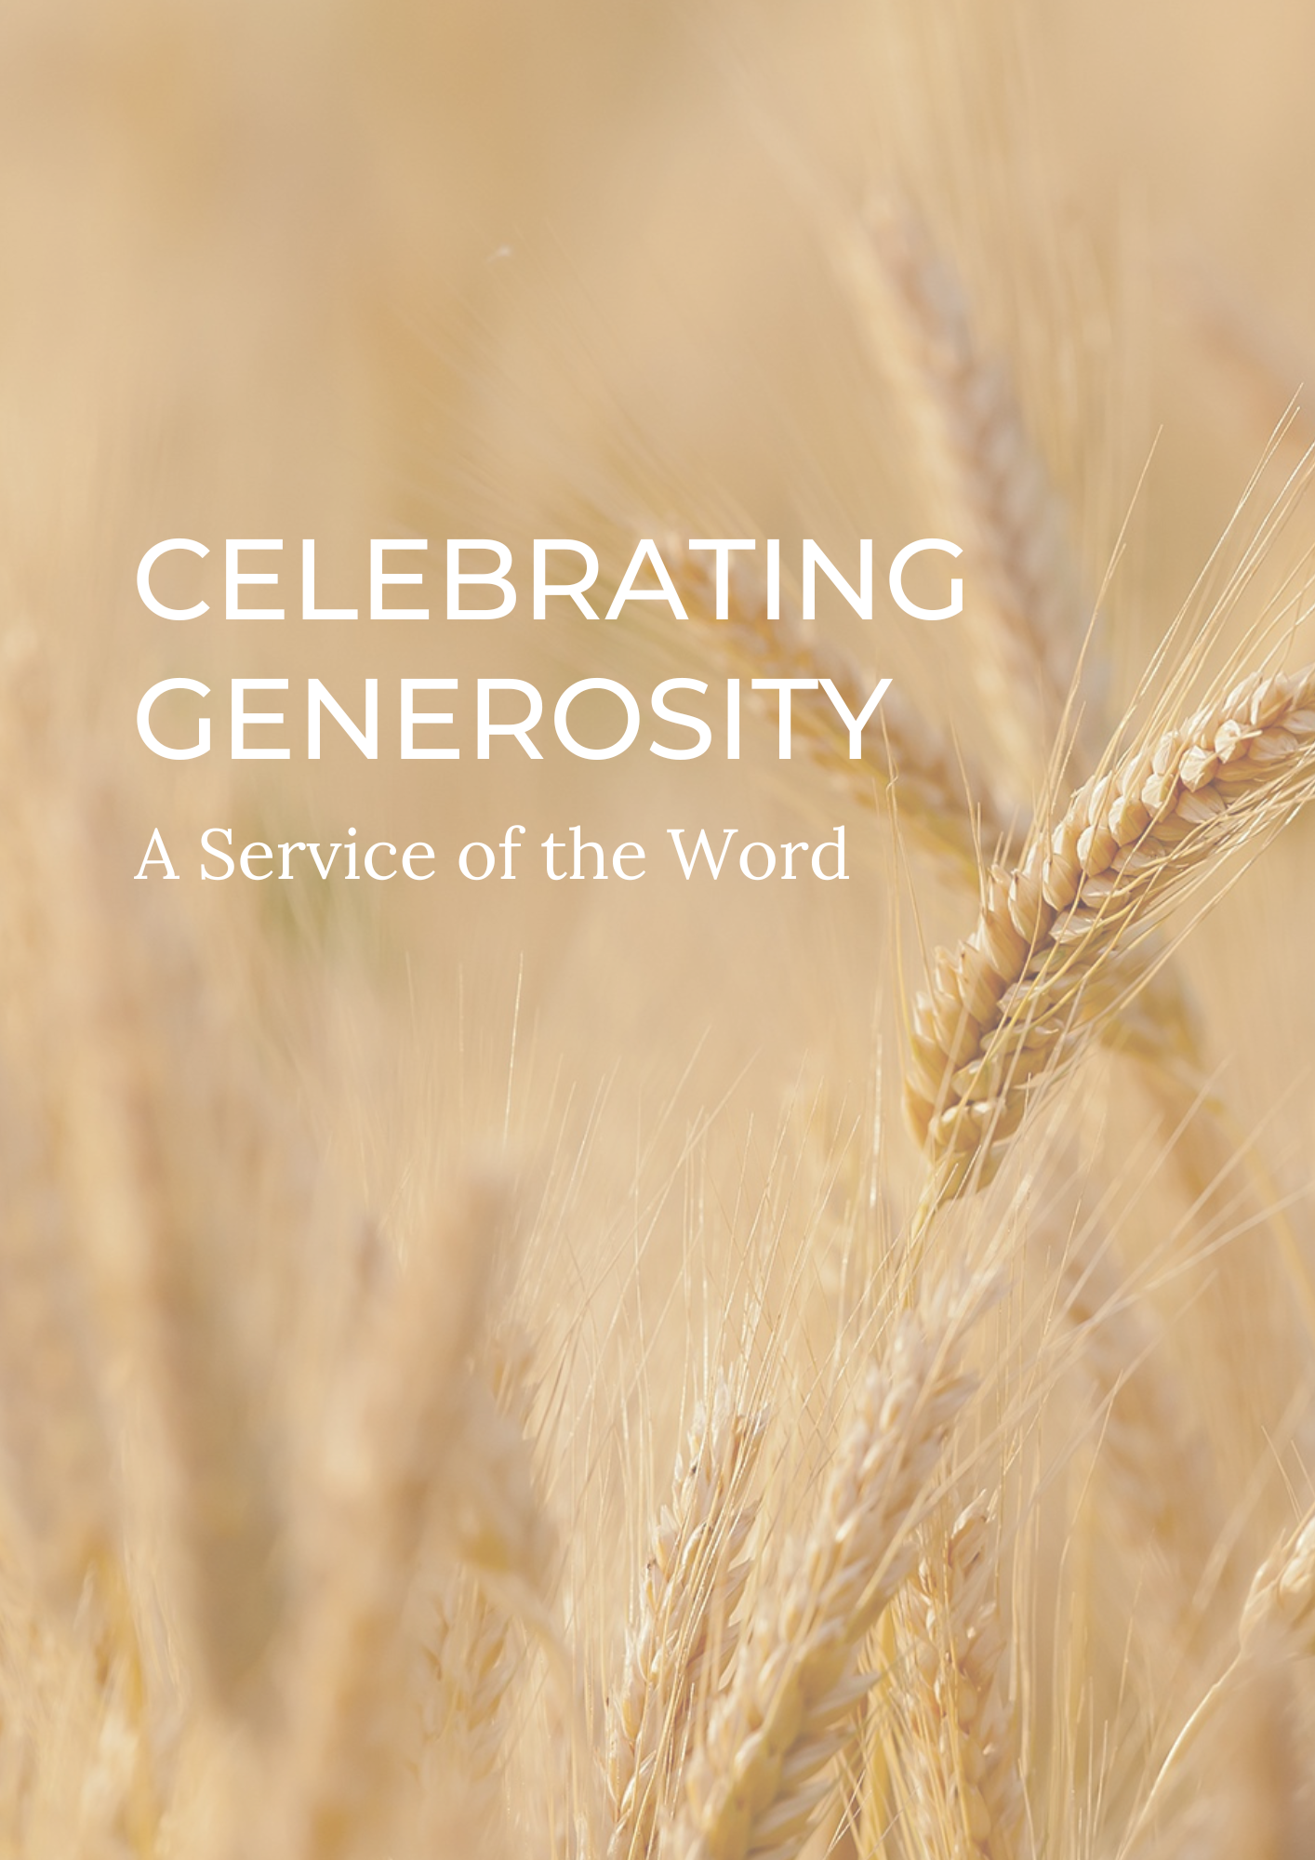

PREPARATION

In preparation for this act of worship, you might wish to pray privately this Ignatian Prayer for Generosity.

Lord, teach me to be generous.
Teach me to serve you as you deserve;
to give and not to count the cost,
to fight and not to heed the wounds,
to toil and not to seek for rest,
to labour and not to ask for reward,
save that of knowing that I do your will.
Amen.
St Ignatius of Loyola

PREPARATION

In the name of the Father,
and of the Son,
and of the Holy Spirit.
Amen.

God is able to provide us with every blessing in abundance,
so that by always having enough of everything,
we may share abundantly in every good work.
cf. 2 Corinthians 9.8

Let everything be said and done in the name of the Lord Jesus,
giving thanks to God through Jesus Christ.
Let us bring our gifts to the Lord
that they may be used for his glory.
May the Spirit of God fill our hearts
as we come to meet him in this place.

Words of welcome or introduction may be said.

Prayers of Penitence

As those who know the generosity of God,
let us confess our sins,
especially the ways in which we take his good gifts for granted.

Father, in creation you are generous towards us,
yet we have sown sparingly;
Lord, have mercy.
Lord, have mercy.

Jesus, you show us the way of humility,
yet we have given reluctantly;
Christ, have mercy.
Christ, have mercy.

Holy Spirit, you show us the gift of grace,
yet we have loved grudgingly;
Lord, have mercy.
Lord, have mercy.

Almighty God,
who in Jesus Christ has given us
a kingdom that cannot be destroyed,
forgive us our sins,
open our eyes to God’s truth,
strengthen us to do God’s will
and give us the joy of his kingdom,
through Jesus Christ our Lord.
Amen.

Canticle: A Song of David

Splendour and majesty are yours, O God;
you are exalted as head over all.

1 Blessed are you, God of Israel, for ever and ever,
for yours is the greatness, the power,
the glory, the splendour and the majesty.
2 Everything in heaven and on earth is yours;
yours is the kingdom, O Lord,
and you are exalted as head over all.
3 Riches and honour come from you
and you rule over all.
4 In your hand are power and might;
yours it is to give power and strength to all.
5 And now we give you thanks, our God,
and praise your glorious name.
6 For all things come from you,
and of your own have we given you.
1 Chronicles 29.10b-13,14b

Glory to the Father and to the Son
and to the Holy Spirit;
as it was in the beginning is now
and shall be for ever. Amen.

Splendour and majesty are yours, O God;
you are exalted as head over all.

The Collect

God of grace, ever creating and restoring,
you breathe life into all things
and embrace us with an everlasting love;
help us to grow in wonder and awe,
to embody a spirit of gratitude,
and to dream generous dreams;
that, in gathering what we have,
we may graciously offer ourselves
to accomplish what you will,
in Jesus Christ our Lord.
Amen.

THE LITURGY OF THE WORD

The First Reading

The Book of Ruth chapters one and two.

Psalmody: Psalm 104.26-36

I will sing to the Lord as long as I live.

26 O Lord, how manifold are your works!
In wisdom you have made them all;
the earth is full of your creatures.
27 There is the sea, spread far and wide,
and there move creatures beyond number, both small and great.
28 There go the ships, and there is that Leviathan
which you have made to play in the deep.
29 All of these look to you
to give them their food in due season.
30 When you give it them, they gather it;
you open your hand and they are filled with good.
31 When you hide your face they are troubled;
when you take away their breath,
they die and return again to the dust.
32 When you send forth your spirit, they are created,
and you renew the face of the earth.
33 May the glory of the Lord endure for ever;
may the Lord rejoice in his works;

34 He looks on the earth and it trembles;
he touches the mountains and they smoke.
35 I will sing to the Lord as long as I live;
I will make music to my God while I have my being.
36 So shall my song please him
while I rejoice in the Lord.

Glory to the Father and to the Son
and to the Holy Spirit;
as it was in the beginning is now
and shall be for ever. Amen.

I will sing to the Lord as long as I live.

Second Reading

Hear the Gospel of our Lord Jesus Christ, according to Luke.
Glory to you, O Lord.

As Jesus looked up, he saw the rich putting their gifts into the temple treasury. He also saw a poor widow put in two very small copper coins.

‘Truly I tell you,’ he said, ‘this poor widow has put in more than all the others. All these people gave their gifts out of their wealth; but she out of her poverty put in all she had to live on.’
Luke 21:1-4 (NIV)

This is the Gospel of the Lord.
Praise to you, O Christ.

A sermon may be given.

Affirmation of Faith

Let us affirm our faith in Jesus Christ the Son of God.

Though he was divine,
he did not cling to equality with God,
but made himself nothing.
Taking the form of a slave,
he was born in human likeness.
He humbled himself
and was obedient to death,
even the death of the cross.
Therefore God has raised him on high,
and given him the name above every name:
that at the name of Jesus
every knee should bow,
and every voice proclaim that Jesus Christ is Lord,
to the glory of God the Father.
Amen. cf Philippians 2.6-11

PRAYERS

A Litany of Generosity

Let us give thanks to God
for his gifts so generous given to us,
and for the blessings we are called to share.

For recognising that all things come from you,
for remembering that we are stewards of your gifts,
for wisely using the resources entrusted to us.
We offer ourselves to you, O God.
For rejoicing in the beauty of creation,
for the care of your world,
for sharing the fruits of creation equally among all people.
We offer ourselves to you, O God.

For encountering the joy of giving,
for humility in putting others’ needs before our own,
for embracing the privilege of sharing in the ministry to the saints.
We offer ourselves to you, O God.

For courage in offering sacrificial generosity,
for giving to be an act of worship,
for grace in offering our souls and bodies to be a living sacrifice.
We offer ourselves to you, O God.

For all financial gifts offered to your Church,
for freely giving as we have received,
for giving and not counting the cost.
We offer ourselves to you, O God.

For releasing our hold on material possessions,
for contentment in what we have,
for trust in letting go.
We offer ourselves to you, O God.

For gathering the harvest,
for thankfulness in all you have given,
for reflecting on what you are calling us to create.
We offer ourselves to you, O God.

For generosity in love, encouragement and hope,
for openness in invitation and hospitality,
for wisdom in the gift of friendship.
We offer ourselves to you, O God.
For serving you as you deserve,
for following our calling as your disciples,
for serving you with gladness of heart.
We offer ourselves to you, O God.

For being a blessing through the blessings we receive,
for generosity which enables mission,
for sharing abundantly in every good work.
We offer ourselves to you, O God.

For living a generous life,
for our actions to point beyond themselves,
for our generosity to be an expression of love and gratitude.
We offer ourselves to you, O God.

Intercessions

Intercessions are offered, and may end with;

Source of all life and giver of all that is good,
hear our prayer,
and make us one in heart and mind
to serve you with joy forever.
Amen.

The Offering

An offering may be taken.
There should be time for people to reflect on gifts given electronically.

God of all creation,
the source of life and giver of all good things;
you have blessed us with all we have.
In our worship we bring now our first fruits:
gifts of gratitude, given in many ways.
With them we offer our lives.
Bless these gifts that they may be used to serve others,
to your praise and glory.
Amen.

CONCLUSION

The God of hope fill us with every blessing,
that we may share in every good work;
and the blessing of God almighty,
the Father, the Son, and the Holy Spirit,
be among you and remain with you always.
Amen.

Go in peace to love and serve the Lord.
In the name of Christ. Amen.

Material in this order of service is taken from Common Worship, copyright © The Archbishops’ Council 2000-2006 and is used here with permission. www.commonworship.com. This order, with adapted offertory prayer, has been compiled by Sammi Tooze. This compilation is copyright © The National Giving Team 2020.

